Sponsored by
the Vermont Agency of Education
and the University of Vermont

PBIS Intent to Implement Application

Instructions:

Please complete this application and send or fax to Anne Dubie
by January 1st for March Universal Training or April 1st for June Universal Training:

- Implementation Partnership Agreement
- Implementation Readiness Checklist
- School Information Profile Form

Anne Dubie
University of Vermont, CDCI
208 Colchester Ave., 307 Mann Hall
Burlington, VT 05405
Fax: (802) 656-1357

Implementation Partnership Agreement
(To be completed by Superintendent & Administrator)

VTPBIS State Team - Supervisory Union/District (SU/SD) Leadership Team - School Leadership Team

By completing this Implementation Partnership Agreement, you are engaging in important steps necessary to implement with fidelity and sustain your effort. The following outlines the commitments of the VTPBIS State Team, the SU/SD Leadership Team and the School Leadership Team:

VTPBIS State Team will:

- Provide technical assistance to SU/SDs and schools in the exploration phase of implementation
- Ensure that SU/SD and School Leadership Teams receive a sequence of trainings*, including:
- Introductory Forums
- Readiness Trainings
- Team Leadership Trainings
*All training activities will be face-to-face, webinar, or other technology.
- Provide ongoing training and technical assistance to SU/SD Coordinators and School Coordinators.
- Coordinate ongoing professional development through a series of topic-based workshops and the BEST/MTSS Summer Institute.
- Facilitate access to data management systems for decision-making and reporting.
- Assist SU/SDs and schools with collecting, interpreting, and action planning around data.

The Supervisory Union/District (SU/SD) Leadership Team will:

- Develop and follow a long-range (3-5 year) plan for implementation with specific goals and strategies consistent with the PBIS framework presented by the State Team*. This implementation plan should be aligned with other SU/SD and school initiatives, and support implementation and sustainability of the intervention in all participating SU/SD schools.
- Ensure that the Implementation Readiness Checklist (attached) is complete and validated by the State-Level Technical Assistance person (TA) for your region.
- Identify a .1 to .2 FTE SU/SD Coordinator for 1-7 schools. The SU/SD Coordinator will:
- Establish a SU/SD Leadership team
- Facilitate the use of data-based decision-making tools for ongoing evaluation
- Communicate with local and state partners
- Access resources for schools needed for implementation
- Participate in ongoing SU/SD Coordinators meetings

The School Leadership Team will:

- Participate in readiness activities, including attending intro/readiness trainings
- Arrange for an awareness presentation for all staff on PBIS and subsequent buy-in vote
- Ensure readiness, as defined by the items on the following Implementation Readiness Checklist
- Participate in Team Leadership Trainings and develop an action plan (see SU/SD Leadership Team Item 1 for description of action plan):
- Identify a .1 FTE building-level School Coordinator. The School Coordinator will:
- Ensure the scheduling and facilitation of monthly leadership meetings
- Attend all SU/SD and Regional School Coordinator meetings
- Support school leadership team in the completion of evaluation tools
- Communicate with local and state partners

*see pages 3 and 4 for more details on the PBIS framework

What is PBIS?

PBIS is a framework or approach for assisting school personnel in adopting and organizing evidence-based behavioral interventions into an integrated continuum that enhances academic and social behavior outcomes for all students. PBIS IS NOT a packaged curriculum, scripted intervention, or manualized strategy. PBIS IS a prevention-oriented way for school personnel to (a) organize evidence-based practices, (b) improve their implementation of those practices, and (c) maximize academic and social behavior outcomes for students. PBIS supports the success of ALL students. PBIS provides a framework for academic and behavioral support as indicated in the triangle below.

School-wide Multi-Tiered System of Supports for Student
Academic and Behavioral Success

Universal Practices in place for 100% of students
80% of Students should be successful when accessing Universal Supports

- All settings, all students
- Preventive, proactive

10-15% of Students may need Targeted Supports
- Some students (at-risk)
- High efficiency
- Rapid response

ALL Students!
Some
Few
1-5% of Students may need Intensive Supports
- Individual Students
- Assessment-based
- High Intensity
PBIS is sustainable due to the organization of systems, data, and practices that contribute to student outcomes, as illustrated in the figure below.

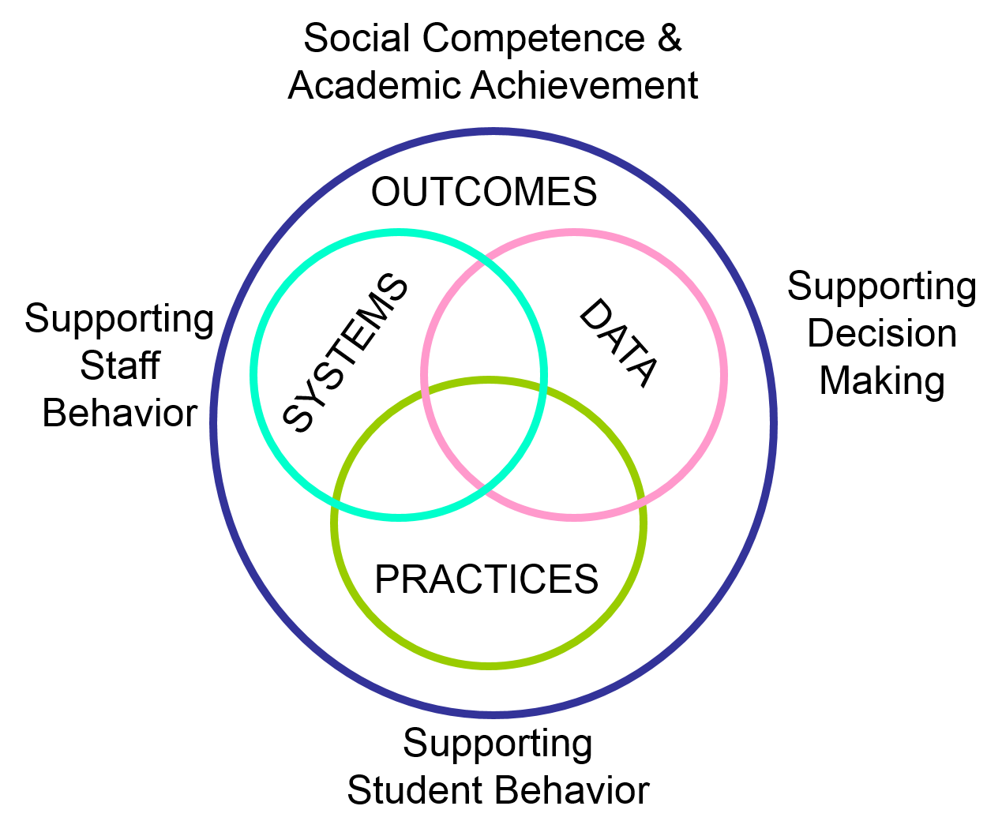

The VTPBIS State Team is actively working to infuse restorative practices principles into the PBIS framework. Restorative Principles include: voluntary participation; exploring relationships; meaningful engagement; participatory decision-making; identification of and addressing harms and needs (rather than focus on rule violation or punishment); active responsibility; restoration and repairing harm.

Partnership Agreement Signature Page:

Superintendent and Administrator are to sign the Partnership Agreement below:

I intend to work with my school and/or SU/SD to fulfill the steps outlined above. I am aware that this involves a commitment to complete the Implementation Readiness Checklist with a score of 100% (yes to all items). My signature below indicates an understanding of this partnership agreement and the intention to dedicate adequate resources as outlined toward this effort.

Date: ___________________

Superintendent Name: __________________________________________________________________
Superintendent Signature: _______________________________________________________________

Date: ____________________

School Administrator Name: ________________________________________________________________
School Administrator Signature: ______________________________________________________________

PBIS Implementation Readiness Checklist
(To be completed by School Coordinator & Administrator)

School: ________________________________________ SU: ___________ Date: __________

Documents / Evidence Complete? |  | Steps to Implementation Readiness
YES | NO | - PBIS is (or will be) one of the top three school goals in the school’s Continuous Improvement Plan.  - Attach a copy of your School’s Continuous Improvement Plan.
YES | NO | - A building-level Leadership Team is formed and has broad representation (i.e. team member(s) with expertise in behavior, administrator(s), school counselor(s), regular and special education teacher(s), community member(s), parent(s), school support staff, student(s))  - List the Leadership Team members and their titles.
YES | NO | - An administrator with decision making authority commits to active participation on the Leadership Team and agrees to attend all team trainings and team meetings.  - List participating Administrator(s).
YES | NO | - The administrator commits to the implementation of the intervention and is aware that implementing an intervention is a 3-5 year process that will require ongoing training and/or revisions of the school’s Implementation Plan.  - Obtain Principal’s Signature of Agreement on Partnership Agreement Form.
YES | NO | - The Leadership Team agrees to commit to (at least) monthly meetings to analyze and problem solve using school-wide data.  - Describe when the Leadership Team will meet throughout the school year (days, location, and time).
YES | NO | - The Leadership Team has participated in an awareness presentation on PBIS.  - Record the date and location of presentation and the presenter’s name(s).
YES | NO | - The school has allocated/secured funding from the SU to support PBIS implementation.  - Identify funding source (BEST/Act 230 grant, etc.).
YES | NO | - An individual at the SU/SD level has been identified as the SU/SD Coordinator at least .1 FTE (4 hours per week) depending on number of schools implementing PBIS (see Implementation Partnership Agreement for SU/SD Coordinator responsibilities).  - Record your SU Coordinator’s name and SU title.
YES | NO | - A building-level School Coordinator has been identified to actively participate in PBIS and is assigned a .1 FTE (4 hours per week) responsibility for this work (see Implementation Partnership Agreement for the building-level School Coordinator responsibilities).  - Record your building-level School Coordinator’s name and school title.
YES | NO | - The school uses, or agrees to develop, work products, practices and procedures that can be used to make data-based decisions regarding PBIS.  - Attach a copy of a work product example, which will assist you making data-based decisions.
YES | NO | - The school has, or agrees to develop, systems and processes to sustain PBIS implementation.  - Describe this process for your school.
YES | NO | - Data entry time is allocated and scheduled to ensure that data will be current to within a week at all times.  - Describe this process for your school.
YES | NO | - The school/SU/SD will cover necessary costs or secure funds to cover costs (e.g., substitutes, food, lodging, etc.) for Leadership Team to participate in trainings.  - Confirm: Yes OR No
YES | NO | - The Leadership Team has arranged for an awareness presentation on PBIS facilitated by someone experienced with PBIS (i.e. State TA, Coach, an implementing school, etc.) for the school’s entire faculty and support staff (all school employees) prior to voting on whether to support PBIS implementation.  - Indicate date of the presentation.
YES | NO | - At least 80% of your faculty, staff, and administration show interest in implementing PBIS as indicated by an anonymous survey/vote.  - Indicate the date and method of obtaining staff buy-in and results (i.e., percentage or range of faculty committed).

What data indicate the need for PBIS in your school and what outcomes is your school hoping to see following PBIS implementation?

__________________________________________________________________________________________

__________________________________________________________________________________________

__________________________________________________________________________________________

__________________________________________________________________________________________

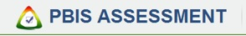
School Information Form

Instructions: If your school has, or is in the process of, implementing Positive Behavior Interventions & Support, please complete this form.

Required fields are marked with an asterisk (*).

School Information
*School Name: |  | *District Name: |  | County:
*Mailing Address: |  | *City: |  | *State/Province: | *Zip/Postal Code:
Physical Address: (if different) |  | City: |  | State/Province: | Zip/Postal Code:
*Phone: |  | Fax: |  | Web Address:
*Grade Levels: (check all that apply)

PrePreK | PreK | K | 1 | 2 | 3 | 4 | 5 | 6 | 7 | 8 | 9 | 10 | 11 | 12 | Post12

*School Administrator: | Phone: |  | *Email:
*PBIS School Coordinator Name: | Phone: |  | *Email:
*PBIS SU/District Coordinator Name: | Phone: |  | *Email:
State PBIS Technical Assistant (TA): | Phone: |  | *Email:
Additional School Information:

Private School? | Juvenile Justice | Other Alternative? | Alternative Behav Prog? | Early Childhood Prog?
Yes No | Yes No | Yes No | Yes No | Yes No

