Using RC/DD Language & PBIS Expectations to
Acknowledge our Students
Positive Feedback Script Examples

Name concrete and specific behaviors. Rather than saying a global “Good job!” or “Nice work,” tell students what they specifically did well so they know what to keep doing and build upon.
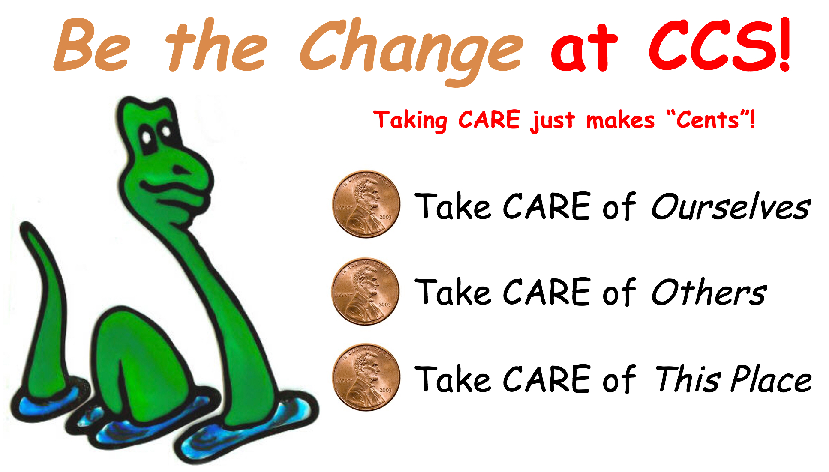
Example Sentence Starters:

I noticed……..

Thank you for……..

I appreciate….

Wow, I just saw………

I just heard……

When you did……….I felt……

Examples of Positive Feedback by School-wide Expectation:

Taking CARE of Ourselves:

“Thank you for having your stuff out and ready to go, that’s taking care of yourself”

“When you wrote down your homework in your planner, you really took care of yourself”

“I noticed you were taking care of yourself by using your walking feet in the hallway”

“Thank you for taking care of yourself by staying in your seat.”

“I appreciate that you asked me for help when you needed it.”

“I noticed that you took care of yourself by dressing appropriately for recess today.”

“Thanks for being on time so we could start this lesson together.”

“Wow! I just saw you use a lot of self-control when things got crazy.”

“I appreciate that you reported that unkind behavior.”

“I just heard you being really polite in the cafeteria.”

“I noticed you had a quiet and calm body during the assembly. Thanks for taking care of yourself.”

Taking CARE of Others:

“I hear you using your inside voice right now. Thanks for taking care of others.”

“I saw you invite a friend who was sitting alone to join your table.”

“I appreciate that you stayed in your own personal space and seat on the bus.”

“Thank you for following all of the bus driver’s directions on the ride to school today.”

“I noticed that you took care of others when you were sharing the sleds at recess.”

“Wow! I just saw you leave room for others to pass on the hallway and you were so quiet as we walked by the classrooms.”

“I just heard you flush the toilet. Thanks for taking care of others!”

“When you kept your hands and feet to yourself in circle, others around you felt safe.”

“I appreciate that you used quiet and respectful words.”

Taking CARE of This Place:

“I noticed that you cleaned up your area. Thanks for taking for taking care of this place.”

“I appreciate that you are reporting a problem in the bathroom.”

“Thank you for separating your compost into the appropriate bin.”

“I noticed that the whole class plugged their chromebooks back in.”

“Wow! I just saw you pick up that trash as we walked in from recess. Thanks for taking care of our school.”

“Thank you for turning off your cell phone during the school day.”

