SUMMER 2020: EDSP 295 - Azores Islands, Portugal: Building Resilience through Family, School, and Community Collaboration

COURSE DESCRIPTION

This course offers students the opportunity to explore education and social service systems outside of the US, in the Azores, a Portuguese archipelago in the middle of the Atlantic Ocean. With a specific focus on family, school, and community partnerships we will visit various schools, social service agencies, and explore Portugal’s progressive public health approach to addiction. Students will participate in a relationship-building service-learning project with Azorian fourth grade students in a fishing village. During our time in Portugal, we will discuss similarities and differences in professional education and social service practice, participate in cultural events, and experience the natural charm of ocean side volcanoes and hot springs. Through cultural immersion, lectures, small group discussions, agency visits, excursions, and informal interaction, students and instructors learn about the issues and challenges faced by education and social services organizations and explore the effects of cultural context on system development.

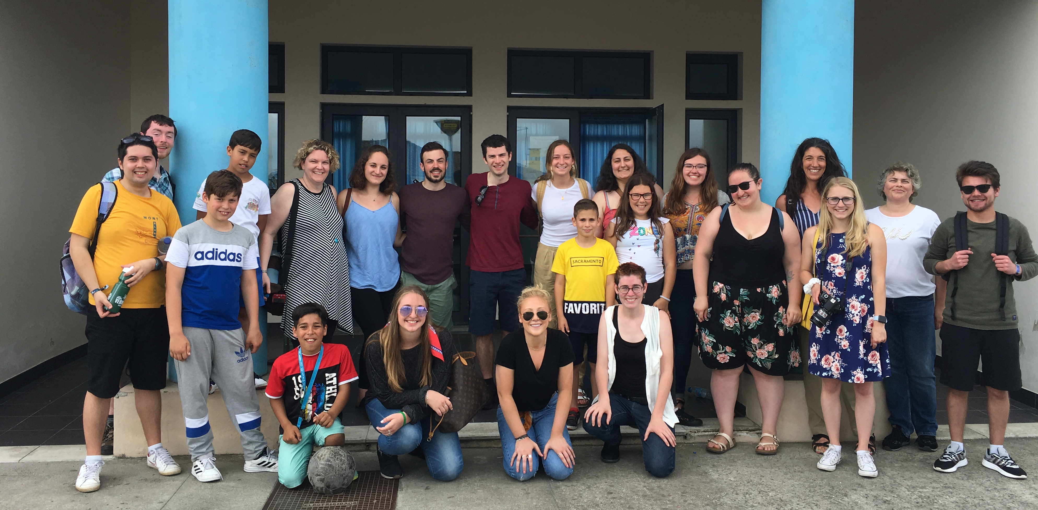
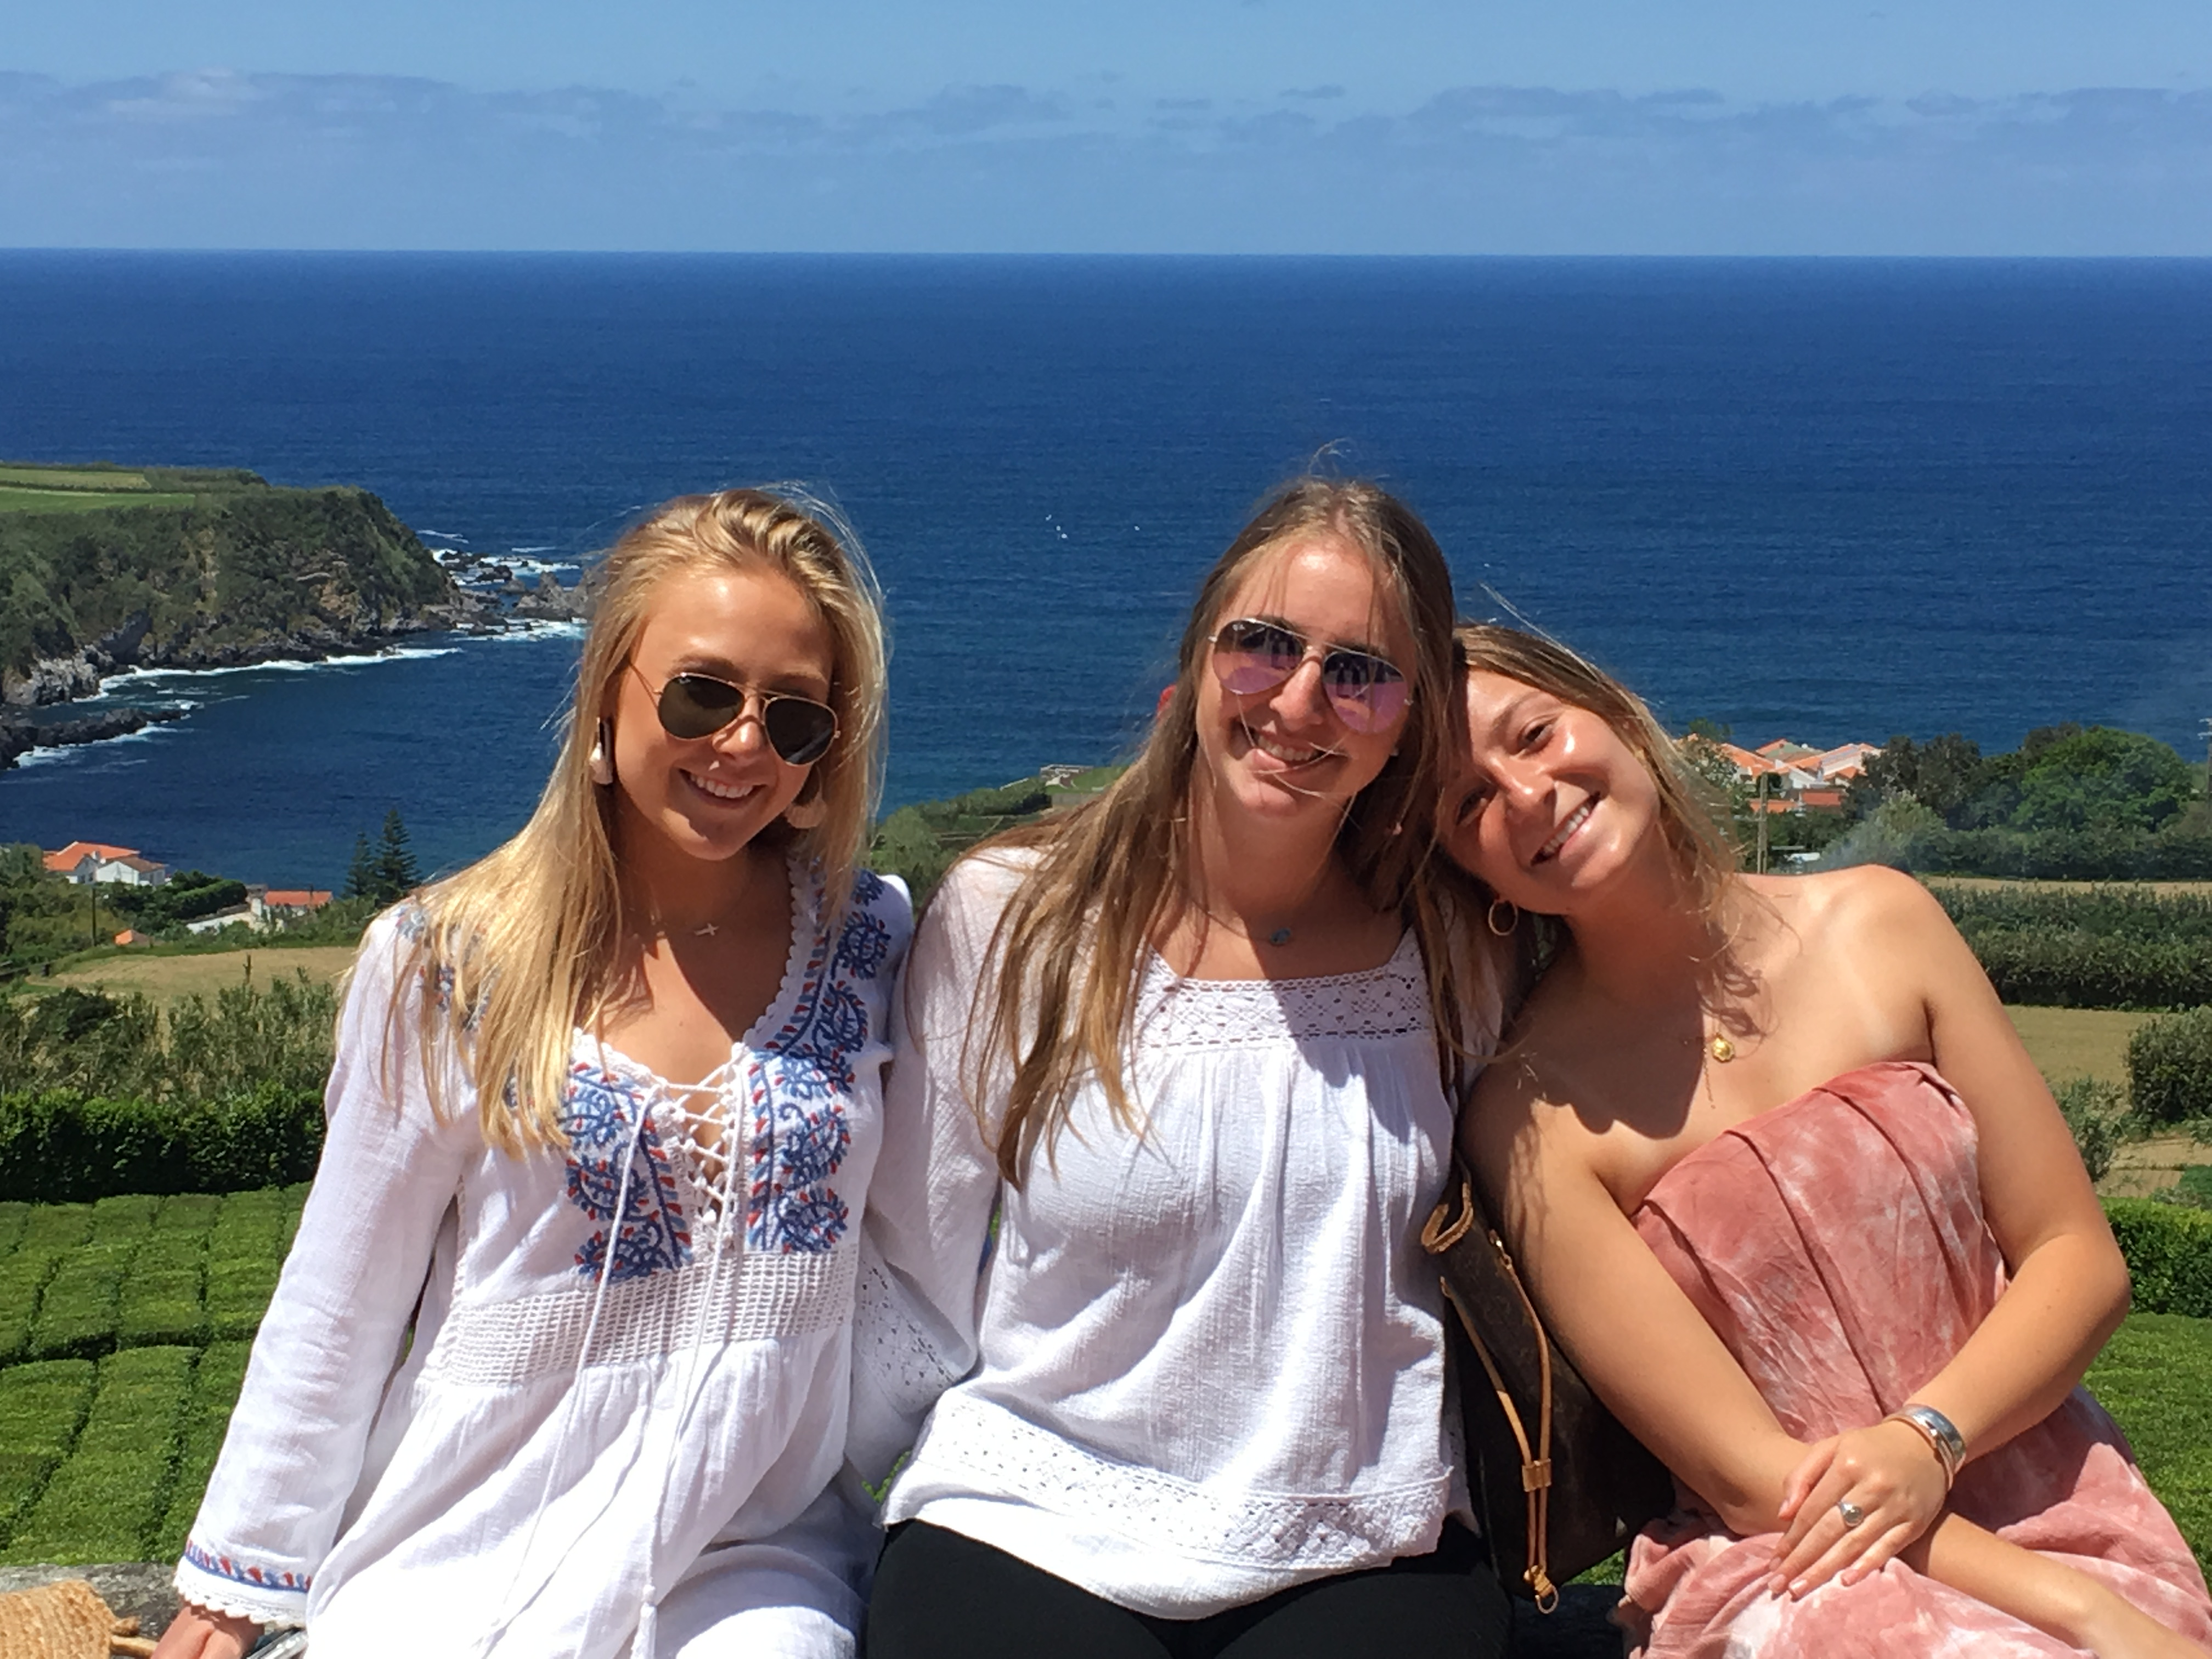
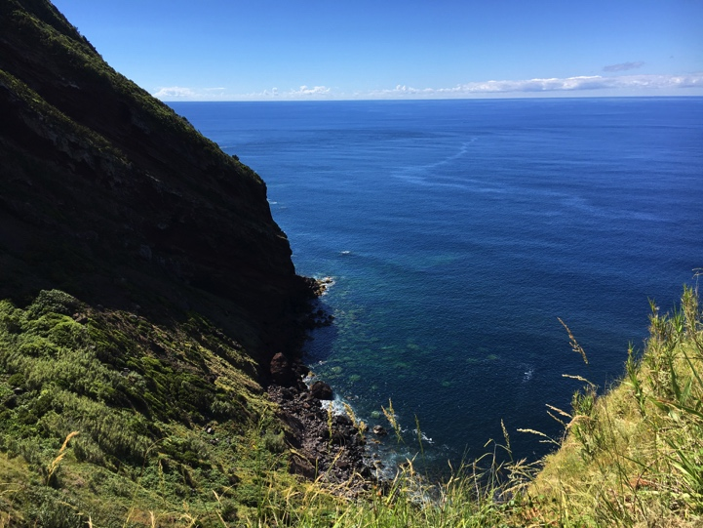
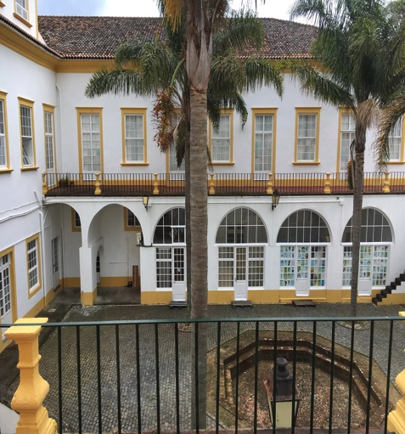

PROGRAM ACTIVITIES

Program Activities include:
- May 19: Orientation to Portugal, San Miguel Island, and Ponta Delgada
- May 20: Cultural Immersion Activity #1
  - Cultural immersion experiences will be planned for the weekends (may include visit to local villages, museums, hot springs, volcanoes, beaches, hiking)
- May 21-22: Community & School Immersion Part 1with Rabo de Piexe Elementary School
- May 23-24: Cultural Immersion Activities
- May 25 26: Community & School Immersion Part 2 with Rabo de Piexe Elementary School
- May 27: Cultural Immersion and Final Course closure
- May 28: Flights home (or continue travel on own)
PREREQUISITES

Eligibility
- Students do not need to speak Portuguese in order to participate in this course.
- The course is primarily for advanced undergraduates, graduate students, and continuing education students interested in professional development (i.e., spec ed teachers and directors). Interested first years and sophomores can enroll with permission of an instructor/s. Please contact Jessica Strolin-Goltzman at jstrolin@uvm.edu for further consideration.
- Final decisions about course acceptance are made by course instructors following an application and interview.

In order to participate in this course, students will need to:
- Have a valid passport.
- Sign a contract with the course instructors about conduct in the Azores.
- Follow all UVM policies and procedures.
HOUSING AND MEALS

Housing
Students will stay in a hostel in the city of Ponta Delgada. Students will share a room with other students.

Meals
Most meals will be included in the course fee.
COSTS AND FEES

The program fee for this course is between $1400-$1600 depending on the number of students enrolled. Students also pay for the following on their own:
- 3-6 credits of UVM summer tuition.
- Airfare to and from Ponta Delgada, Portugal.

