CICO-SWIS Readiness Checklist
Check In Check Out SWIS
School/Facility: ___________________________ Certified CICO-SWIS Facilitator: _________________________ Date: _______________
CICO-SWIS Requirements | Data Source | Status |  |  | Next Check
 |  | Not in place | Partial | In Place
1. Building administrator supports the implementation and use of the Check In Check Out Intervention and CICO-SWIS. | Administrator Interview
2. A school/facility-wide behavior support team exists with access to training and support for the CICO Intervention and reviews CICO-SWIS data at least twice monthly. | Team Roster & Meeting Schedule
3. The school/facility has a CICO point card with the following information:  - Standard for all students  - Defined number of check-in periods (up to ten)  - Defined number of expectations/goals (3-5)  - A three-point rating scale | CICO Point Card
4. Within three months of CICO-SWIS licensing, the school/facility is committed to having a clearly documented CICO system. Procedures include:  - Description of program  - CICO Coordinator  - Process for identifying students for CICO  - Process/materials for training adults, students, and families | Written Guidelines
5. Data entry time and staffing are scheduled to ensure that point card data will be current to within three days at all times. Data entry staff have access to all necessary information (e.g., student records). | Data Entry & Report Generation Schedule
6. A small number of people within the school/facility are identified to gain CICO-SWIS access and are scheduled to attend a 90-minute Swift at CICO-SWIS Training conducted by a certified CICO-SWIS Facilitator. | Specific Date, Time, Location, Computers, Internet
7. The school/facility agrees to maintain technology (i.e., internet browsers, district permissions) compatible with CICO-SWIS. | Administrator/ Coordinator Interview
8. The school/facility agrees to both initial and ongoing coaching and support on the use of CICO-SWIS with a certified CICO-SWIS Facilitator. | Administrator/ Coordinator Interview
9. The school/facility agrees to maintain CICO-SWIS readiness/compatibility. | Administrator/ Coordinator Interview

Items that are Not in Place or Partially in Place can be organized into an action plan.

Daily Progress Report Cards and CICO-SWIS Readiness Requirements

School A: Compatible format for CICO-SWIS Data Entry
This format is used for all students participating in CICO

Name:  Date: | Safe | Responsible | Respectful
Check In | 2 1 0 | 2 1 0 | 2 1 0
Before  Recess | 2 1 0 | 2 1 0 | 2 1 0
Before  Lunch | 2 1 0 | 2 1 0 | 2 1 0
Before Recess  mid afternoon | 2 1 0 | 2 1 0 | 2 1 0
Check Out | 2 1 0 | 2 1 0 | 2 1 0
Key= 2 great job  1 did OK  0 had a difficult time |  | Today’s total points

School B: Compatible format for CICO-SWIS Data Entry
This format is used for all students participating in CICO

Name:
Date:
Key= 2 did my best  1 OK  0 tough time | Block 1 | Block 2 | Lunch | Block 3 | Block 4
Safety | 0 1 2 | 0 1 2 | 0 1 2 | 0 1 2 | 0 1 2
Organization | 0 1 2 | 0 1 2 | 0 1 2 | 0 1 2 | 0 1 2
Achievement | 0 1 2 | 0 1 2 | 0 1 2 | 0 1 2 | 0 1 2
Respect | 0 1 2 | 0 1 2 | 0 1 2 | 0 1 2 | 0 1 2

School C: Incompatible format for CICO-SWIS Data Entry
- This format has:
  - More than ten check in periods
  - A 4 point rating scale
  - A different set of goals and number of check in periods for each student

Name:  Date: | Pencil sharpened | Homework completed | Raise hand to talk | Be on time | Keep hands to self
1. Check in | 1 2 3 4 | 1 2 3 4 | 1 2 3 4 | 1 2 3 4 | 1 2 3 4
2. Reading | 1 2 3 4 | 1 2 3 4 | 1 2 3 4 | 1 2 3 4 | 1 2 3 4
3. Music on MWF | 1 2 3 4 | 1 2 3 4 | 1 2 3 4 | 1 2 3 4 | 1 2 3 4
4. PE on T TH | 1 2 3 4 | 1 2 3 4 | 1 2 3 4 | 1 2 3 4 | 1 2 3 4
5. Math | 1 2 3 4 | 1 2 3 4 | 1 2 3 4 | 1 2 3 4 | 1 2 3 4
6. Lunch | 1 2 3 4 | 1 2 3 4 | 1 2 3 4 | 1 2 3 4 | 1 2 3 4
7. Recess | 1 2 3 4 | 1 2 3 4 | 1 2 3 4 | 1 2 3 4 | 1 2 3 4
8. Reading | 1 2 3 4 | 1 2 3 4 | 1 2 3 4 | 1 2 3 4 | 1 2 3 4
9. Language arts | 1 2 3 4 | 1 2 3 4 | 1 2 3 4 | 1 2 3 4 | 1 2 3 4
10. Snack | 1 2 3 4 | 1 2 3 4 | 1 2 3 4 | 1 2 3 4 | 1 2 3 4
11. Research projects | 1 2 3 4 | 1 2 3 4 | 1 2 3 4 | 1 2 3 4 | 1 2 3 4
12. Preparing to go home | 1 2 3 4 | 1 2 3 4 | 1 2 3 4 | 1 2 3 4 | 1 2 3 4
13. Check out | 1 2 3 4 | 1 2 3 4 | 1 2 3 4 | 1 2 3 4 | 1 2 3 4
1= not good
2= so-so
3= good
4= fantastic

School D: Compatible format for CICO-SWIS Data Entry
This format is used for all students participating in CICO
More specific goals are used for individual students as prompts through the day
Name: | Safety | Organization | Achievement | Respect
Date: | Keep hands to self | Turn in homework | Do my own work | Raise hand to talk
Block 1 | 0 1 2 | 0 1 2 | 0 1 2 | 0 1 2
Block 2 | 0 1 2 | 0 1 2 | 0 1 2 | 0 1 2
Block 3 | 0 1 2 | 0 1 2 | 0 1 2 | 0 1 2
Block 4 | 0 1 2 | 0 1 2 | 0 1 2 | 0 1 2

School E: Compatible format for CICO-SWIS Data Entry
This school has a block schedule with 4 periods scheduled on Red days and 4 periods scheduled on Blue Days. Each student attends 4 periods per day. Daily Data Entry in CICO-SWIS will include 4 red periods one day and 4 blue periods on the alternate day. CICO-SWIS data entry has red 1-4 and blue 1-4 periods daily. On red days, red periods 1-4 get points entered and blue periods 1-4 get blanked out as not relevant for data entry that day.

Red/ Blue | Perseverance | Respect | Integrity | Discipline | Excellence
1 | 2 1 0 | 2 1 0 | 2 1 0 | 2 1 0 | 2 1 0
2 | 2 1 0 | 2 1 0 | 2 1 0 | 2 1 0 | 2 1 0
3 | 2 1 0 | 2 1 0 | 2 1 0 | 2 1 0 | 2 1 0
4 | 2 1 0 | 2 1 0 | 2 1 0 | 2 1 0 | 2 1 0

This is what the CICO-SWIS data entry screen for each student looks like for School E.

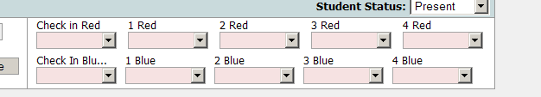

School F: Compatible format for CICO-SWIS Data Entry
This school has the data entry person convert the faces to points as defined on the H.U.G Progress Report.

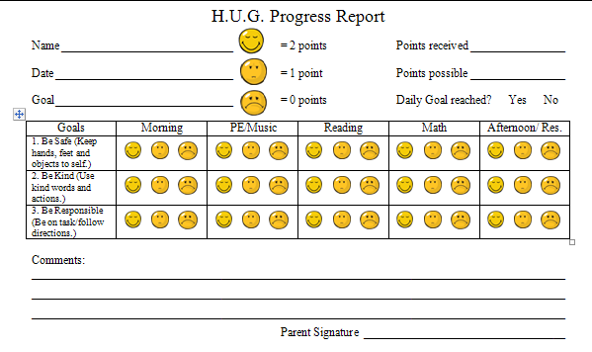
SWIS Data Entry and Report Generation Schedule
Using SWIS Data For Decision Making

Today’s date _____ Next review date ______
Universal Team Coordinator ___________CICO Coordinator___________
SWIS data entry person & time _______________CICO-SWIS data entry person & time _______________

What questions do we have ? | What reports are needed?  Do we have what we need? | Who needs the reports & when? | Who will generate the report by when?
How are we doing SW with problem behaviors? Is there a problem?  Where, what, when, whom, and what is maintaining the problem?  Are any individual students showing early signs of problem behavior patterns  (2+ BODs)? | Big 5 SWIS Reports  By Student Report | SW PBS Team | Who:  When:
How is the CICO program working?  How are students on CICO doing, in general?  How many students needing intensive/tertiary support?  Does the team have what they need? | - School wide Report  - Average Daily Points per Student | SW PBS Team | Who:  When:
How are students using CICO doing?  Any students needing discussion?  How is CICO program working? | - Individual Student Count Report  - Individual Student Period Report  - Average Daily Points per Student | Individual Student Support Team | Who:  When:
How is each student using CICO doing?  If student is having problem, ask: where, where, what, why questions | - School wide Report  - Average Daily Points per Student  - Individual Student Count Report  - Individual Student Single Period Report  - Individual Student Period Report | CICO Coordinator | Who:  When:
How accurate are our data? | - Data Integrity Report | All | Who:  When:

