VTPBIS Targeted Level
(Insert School Name and Logo Here)
Staff Handbook
(Insert School Year)

Developed by the following school staff: ___________________________________________________
______________________________________________________________________________________________________

Revised Date: (Always update date when revisions are made)

The purpose of this Handbook is to share the critical features of what PBIS at the targeted level looks like in our school. This handbook will be updated on an annual basis and available to all members of our school’s faculty and staff.

This Handbook is directly linked to the PBIS framework, and emphasizes a specific exemplar, Check-In Check-Out (CICO), an evidence-based, group-oriented intervention Targeted prevention program.
What is School-wide Positive Behavioral Interventions and Supports (SW-PBIS)? SW-PBIS is a framework for enhancing adoption and implementation of a continuum of evidenced-based interventions to achieve academically and behaviorally important outcomes for all students.

PBIS targeted interventions are one component of a continuum of behavioral supports, and their features and systems reflect the structure of School-wide PBIS. They are evidence based, utilize teams to make data-based decisions, require systems-level support, and emphasize prevention. These targeted systems and practices focus on both school-wide and individual student outcomes.

What is the purpose of Targeted Interventions? The three-tiered prevention logic (below) organizes behavior supports along a continuum, matching intervention intensity to students’ needs. Targeted interventions have been designed to:
- Prevent the development or decrease the frequency and/or intensity of students’ problem behaviors
- Provide standardized interventions that effectively and efficiently support students, yet do not require the time and resources needed to develop individualized plans

PBIS Three-Tiered Logic Model
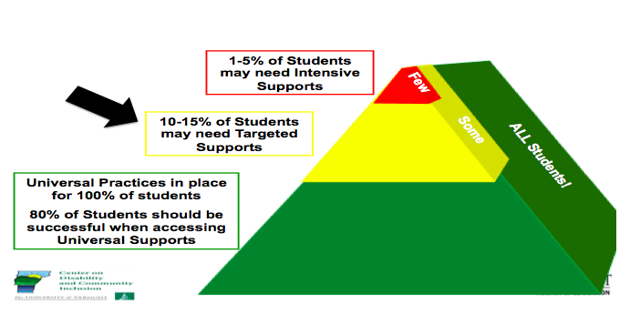

What are Targeted Interventions?

“3•9•3”

3 Functions of Targeted Interventions:

- For low-level problem behavior (e.g. talk-outs, minor disruption, task completion)
- Efficient because they use the same or similar practices for groups of students that do not need to be individualized for each student
- Effective because they focus on decreasing problem behavior, thereby increasing academic engagement and decreasing office discipline referrals

9 Critical Features of Targeted Interventions:

- Meets the needs of groups of students
- Does not require individualizing for each student
- Uses positive approach
- Everyone knows about it
- Lets students opt out
- Involves parents
- Based on function of behavior (get or avoid)
- Has some clear evidence that it works
- Has system resources (team and administrator support)

3 Reasons to Consider Targeted Interventions:
- When universal systems are not sufficient to impact behavior
- When students display chronic patterns of disruptive behavior
- When concerns arise regarding students’ academic or social behavior

Two Purposes of Targeted Planning

- Systems level design and accountability
• Creates procedures for all targeted interventions (not individual students)
• Communicates to staff and families
• Links between Targeted and Universal systems

- Individual student intervention planning and monitoring
• Meets weekly or bi-weekly to review student requests for assistance and place student on CICO
(unless otherwise specified)
• Communicates with staff and parents about student
• Evaluates student progress, needed plan change and exit from interventions
• Members include a coordinator, individual skilled in function-based behavior support
planning, administrator

Team Profile: Insert your team profile here
Implementation Team Roster
School Name: Grades:
Town/City: Supervisory Union:

Implementation Team – Systems Level

Team Member Name Building Role Team Member Role
(facilitator, timekeeper,
recorder, other)
Day and Time of Monthly Meetings:

Team Norms:

Individual Student Level Team
Team Member Name Building Role Team Member Role
(coor., behavior spec., data spec.) (facilitator, timekeeper,
recorder, other)
Day and Time of Weekly Meetings:

Insert your Targeted Team Purpose Statement

- Targeted Team Purpose Statement:

Functional Behavioral Assessment

Understanding the function of problem behavior is important for matching students to interventions that address the function. This involves assessing predictable relationships between the environment and behavior and can include asking the following questions:
What is the problem?
What is he/she getting out of it or avoiding?
What do you want him/her to do instead?
How can you help this happen more often?
How will you know if it works?

It will be important to ask these questions when matching student needs to interventions. At times, a Functional Behavioral Assessment and Behavior Support Plan (FBA/BSP) will need to be conducted for students whose needs are not clearly known. The process for accessing FBA/BSP at this school is as follows:

Insert your FBA/BSP Process

- Names of people trained to conduct FBA/BSP

- Request for assistance process for FBA/BSP

- Timeline of process from referral to creation of BSP

- Process for review of FBA/BSP

Insert Your Inventory of Targeted Interventions

Intervention System Support or Practice | Function of Behavior |  |  |  | Purpose/Goal | Staff Involved | Referral  Criteria | Evidence of Effectiveness (Does practice achieve anticipated outcomes? Is there data?)

Check-In/Check-Out (CICO) and/or Teacher Check, Connect and Expect (TCCE)?

School-based programs for providing systematic and frequent reinforcement and encouragement for positive behaviors so that the student receives high rates of immediate feedback. Most useful with:

• Students who do not respond to school-wide interventions
• Students with repeated referrals
• Students seeking adult attention

Check-In/Check-Out (CICO)
How does it work?

1. Morning check-in
• Students checks in with coordinator within 15 minutes of arrival time
• Coordinator collects and hands out Daily Progress Report (DPR) form
• Daily goal set with students
• Students encouraged to make good choices

2. Student gives DPR form to each teacher prior to each period (section of time).
(Can also be used in cafeteria or playground… anywhere there is a supervisor).

3. End of day check-out

• During last 20 minutes of the day
• Goes over daily progress
• Reviews progress towards goals
• Points tallied
• Reward
• Graphs student progress

4. Daily Progress Report form copy taken home and signed.

5. Return signed copy next morning.

Teacher Check Connect and Expect (TCCE):
How does it work?

- Student is greeted in a friendly positive way by the teacher.
- Teacher reviews behavior expectations with the student, and encourages student to do well.
- After each time period, teacher checks in with student about progress during time period and indicates points on daily progress report (DPR).
- At end of day, teacher writes the total amount of points achieved for the day on DPR.
- Completed DPRs are sent to the targeted team for input into data information system.

With both CICO and TCCE Targeted Team reviews progress after four weeks unless otherwise indicated.

Insert Process for how CICO or TCCE will be implemented in your school
Insert your Request for Assistance Process
- Describe the CICO or TCCE program (or both) at your school include a name for the program, if applicable.
- Name and contact info of CICO Coordinator (if CICO).
Location of Check-in/Check-Out
Criteria for placing students on Check-In/Check-Out

Request for Assistance Process
Insert your Request for Assistance Form
Insert your Student Agreement or Contract
(see BEP book page 219)

Insert your Parent Permission Process
Develop a parent consent form (see sample at https://www.pbisvermont.org/resource/dbs-parent-permission/)

Insert Daily Progress Report (DPR)

Insert your Reinforcement System

Student’s daily points goal will be...
Reinforcers for students will include...
Reinforcers at check-out will include...

Insert system for managing the daily data

Describe the data system will you use.

Describe how frequently will your team review the daily Check-In/Check-Out data. (at least bi-weekly)

Describe how frequently summary data will be shared with staff? Parents?

Insert plan for fading students off the Check-In/Check-Out intervention

Describe the criteria for fading students off of Check-In/Check-Out.

How will the program be faded, and who will be in charge of helping students fade off the Check-In/Check-Out?

