VTPBIS Leadership Team Training
at the Targeted Level
Within a Multi-Tiered System of Supports

Activity Workbook

Name: _______________________________

School: _______________________________

Activity #1: Leadership Team Meeting Norms and Roles

Team Norm | What does it look like?
1.

2.

3.

4.

5.

Team Roles:
- Facilitator
- Notetaker/Recorder
- Timekeeper
- Reporter
- Process Observer
- Encourager
- Other: _____________________________

Activity #2:
The Heart of the Matter
Team Exercise

Knowing and honoring what strengths our students bring with them to our school community is the first step. Listen to the following story:

What they don’t understand about birthdays and what they never tell you is that when you’re eleven, you’re also ten, and nine, and eight, and seven, and six, and five, and four, and three, and two, and one. And when you wake up on your eleventh birthday you expect to feel eleven, but you don’t. You open your eyes and everything’s just like yesterday only it’s today. And you don’t feel eleven at all. You feel like you’re still ten. And you are – underneath the year that makes you eleven. Like some days you might say something stupid, and that’s the part of you that’s still ten. Or maybe some days you might need to sit on your mama’s lap because you’re scared, and that’s the part of you that’s five. And maybe one day when you’re all grown up maybe you will need to cry like if you’re three, and that’s okay.

That’s what I tell Mama when she’s sad and needs to cry. Maybe she’s feeling three. Because the way you grow old is kind of like an onion or like the rings inside a tree trunk or like my little wooden dolls that fit one inside the other, each year inside the next one - That’s how being eleven years old is. You don’t feel eleven. Not right away. It takes a few days, weeks even, sometimes even months before you say eleven when they ask you. And you don’t feel smart at eleven, not until you’re almost twelve. That’s the way it is.

- Sandra Cisneros; Excerpted from Woman Hollering Creek and Other Stories

Directions:
- List the initials of at least 5 students you have worked with or whom you know well.
- Next to each student’s initials, write at least one strength (special talent, characteristic, etc.) you believe this student possesses.
- Finally, circle the student’s initials ONLY if you are CERTAIN that he/she KNOWS that you recognize at least one of their gifts (you have acknowledged their gift verbally or in some other way).

Questions:
- Does anyone else at school (adults or students) recognize or acknowledge these student’s strengths?
- What 2-3 things can you do to help these student’s strengths be recognized by yourself and others?

Leadership Team Activities Prior to Targeted Training

Activity #3: View the VTPBIS Family Engagement at the Targeted Level Learning Module

As a team, view the learning module at https://www.youtube.com/watch?v=1w3DDUNJrbM:
- Complete Family Engagement Checklist (below) and create action steps
- Review Family Engagement resources at: https://www.pbisvermont.org/training-resources/family-engagement/

STATUS:  In place  Partially in place  Not in place | Family Engagement Checklist (Muscott & Mann, 2004)  TASK | PRIORITY:  High  Medium  Low
 | Climate
 | 1. There is a process for assessing how welcomed, valued, and satisfied parents are in and with the school.
 | 2. There is a plan for addressing ways to help families feel welcomed and valued.
 | 3. There is a plan for training all staff to work collaboratively and respectfully with families.
 | 4. Plans for addressing ways to help families feel welcomed and valued address diverse families including those with students in the universal, targeted and intensive levels of PBIS.
 | Parent Involvement in Learning Activities at Home
 | 5. There is a process for assessing parents’ opinions about their own involvement in learning activities at home.
 | 6. There is a plan or set of activities for helping families to support their child’s learning at home.
 | 7. The plan includes activities for helping diverse families, including those with students in the universal, targeted and intensive levels of PBIS, support their child’s learning.
 | Communication with Parents/Families
 | 8. There is a process for assessing parents’ opinions about how well schools communicate with them.

9. There is a plan for communicating with families in varied and

helpful ways.

10. The plan includes activities for communicating with diverse families, including those with students in the universal, targeted and intensive levels of PBIS, about important school/home matters including discipline.

Parent/Family Involvement at School (Volunteering, Assisting)

11. There is a process for assessing parents’ opinions about how they can support schools through their involvement at school.

12. There is a plan for how parents can be involved in supporting learning at school through volunteering and assisting.

13. The plan for parental involvement in school activities addresses how diverse families, including those with students in the universal, targeted and intensive levels of PBIS, can participate.

Parent/Family Involvement in Decision-Making

14. There is a process for assessing parents’ opinions about the extent to which they are encouraged to participate in decision-making committees and activities (e.g., leadership teams).

15. There is a plan for encouraging and supporting parent participation in decision-making committees and activities.

16. The plan for parental participation in decision-making committees and activities addresses how diverse families, including those with students in the universal, targeted and intensive levels of PBIS, can participate.

17. There is a process for assessing parents’ opinions about the extent to which they can provide input to school personnel about matters of importance including discipline that is taken seriously.

18. There is a plan for gathering and incorporating parents’ input about matters of importance including discipline that is taken seriously.

19. The plan for gathering and incorporating parents’ input about matters of importance including discipline addresses how diverse families, including those with students in the universal, targeted and intensive levels of PBIS, can be heard.

Activity #4: Plan to sustain the Universal Level

As a team, answer the following questions and complete the Checklist for Sustainability below:

- Who’s missing from the team?

- What steps can you take to make the team have a higher profile in the school?

- How will you use data to help in your planning?

- What competing initiatives (school improvement activities) do you need to align with PBIS?

- Review your school’s TFI at Tier 1.

6. Complete the VTPBIS Universal Action Plan for Sustainability.

Universal Level Behavior Action Plan for Sustainability
Adapted from Muscott & Mann 2008

TASKS
Faculty and Staff | Action? | Who? | When?

1. Review the elements and procedures of Universal PBIS (expectations, teaching plans, problem behavior definitions, reinforcement, BOD form, procedures for referral to the office, etc.) with ALL staff and faculty.

2. Develop a plan for obtaining annual staff buy-in for PBIS.

3. Develop a plan for orienting new and substitute faculty and staff to Universal PBIS.
Students | Action? | Who? | When?

4. Review the elements and procedures of Universal PBIS (expectations, acknowledgment system, lessons, procedures for addressing problem behavior) with ALL students.

5. Students will be taught the expectations in the various school environments.

6. Students will be acknowledged/rewarded for exhibiting are the behaviors associated with the schoolwide expectations.

7. A plan for Booster activities (reteaching, reinforcement) based on need and data will be developed.

8. A plan for orienting new students to Universal PBIS will be established.
Families/Community | Action? | Who? | When?

9. A plan for communicating and discussing the PBIS Universal System to families will be developed.

10. A method for gathering and responding to family input regarding school-wide PBIS has been developed.

11. A plan for orienting new families to Universal PBIS will be developed.

LOGISTICS | Action? | Who? | When?
12. Posters developed and printed for classroom and non-classroom areas.
13. Matrix developed and printed for classrooms, student handbooks, non-classroom areas.
14. Acknowledgement tangibles (tickets) developed and printed with directions printed for staff.
15. Acknowledgements menu developed and printed.
16. Personnel to manage SWIS or other data system identified.
17. Kick off activities planned.
18. Teaching activities planned.
19. Adult incentives planned.
20. Office Discipline Referral form finalized and printed.
21. Parent kick-off planned.

Activity #5: Who will benefit from Targeted Supports

- If up to 15% of your students need something more, how many students would that be in your school?

- Review your BOD data (if using SWIS, look at “referrals by student graph”). What percentage of your students receives 3-5 BODs? Calculate based on your school enrollment.

- Make a list of students who may benefit from Targeted Supports.

Activity #6: Team Profile

- In your Staff Handbook, complete your Team Profile at the Systems Level and Student Planning Level.

Activity #7: Targeted Team Purpose Statement

1. In your Staff Handbook, complete your Targeted Team Purpose Statement.

Activity #8: Inventory of Targeted Supports

- In your Staff Handbook, complete your Inventory of Targeted Supports.

Activity #9: Process for FBA/BSP

- As a team, complete as many of the following questions as possible. Then summarize in your process in the Staff Handbook.

Determine who needs to be trained in FBA:
1)
2)

(To be completed after team members have been trained in conducting Simple/Full FBAs):

Who makes the referral?

What form do they use?

Where or to whom does the referral form go?

Who or what group reviews the referral form to see if Simple FBA needs to be done?

Who schedules the Simple FBA, informs teachers and others who need to know?

Who completes the Simple FBA? Assign a “FBA Coordinator”

Who or what group develops the testable hypothesis?

Who or what group develops the simple behavior support plan?

What is the proposed timeline from referral, decision, interview(s), summary of Simple FBA, testable hypothesis statement and development of simple behavior support plan?

When and by whom is BSP reviewed to see if it is working?

Who else needs to be trained to complete Simple FBA?

Activity #10: Describe your CICO or TCCE Process

- Look at the 15% identified students in your BOD data. Determine a group of students whose problem behavior is motivated by peer or adult attention.

- Looking at the definition of CICO and TCCE, what additional information do you need to make this doable at your school?

- As a group, look at the advantages/disadvantages of each (T-Chart).

CICO: More evidence of working; a designated person who checks in at beginning/end of the year
(more fidelity).
TCCE: The child comes to the teacher—teacher follows plan.
- Determine which of the two strategies your team will implement. What challenges can you identify that you will work through as we proceed?

- Describe the CICO Process in your Staff Handbook

Activity #11: Create your DPR Form

- Create a DPR form that contains the following information:
  - Expectations should match Universal expectations
  - DPR should be teacher and student friendly
  - There should be a place to write each student’s goals
  - Defined number of check-in periods (up to ten)
  - A three-point rating scale (0, 1, 2)

  - Use Examples from the book Responding to Problem Behavior in Schools: The Behavior Education Program pages 201-204 and the example DPR forms at the end of this document (pgs. 23-25).
  - Use SWIS and SWIS CICO Readiness Checklist for DPR compatibility.

2. Insert your DPR form in the Staff Handbook.

Activity #12: Create your CICO or TCCE Reinforcement System

1. What will the student’s daily point goal be?

- What reinforcers will students receive for checking in and out (e.g., praise and lottery ticket)?

- What reinforcers will students receive for checking out and meeting their daily point goal?

- What resources will you need to access reinforcers?

- How is the reinforcement for CICO or TCCE tie in with school-wide reinforcement system?

- Insert description of your CICO or TCCE reinforcement system in your Staff Handbook.

Activity #13: Create your Request for Assistance Process

- Describe process for referring students to CICO or TCCE or other targeted interventions:
  - What are the criteria for placing students on Check-In/Check-Out? Other targeted interventions?
  - How will students be referred?

- See BEP book page 197 and Request for Assistance form. Are the forms easy to access? Easy to complete? Contain the necessary information?

- Create a Student Agreement or contract (see BEP book page 219).

- Develop a parent consent form (see sample at https://www.pbisvermont.org/resource/dbs-parent-permission/).

- Insert Request for Assistance Form, Student Agreement form, and Parent Consent form into your Staff Handbook.

Activity #14: Create a system for managing the daily data

- Which computer system will you use? SWIS-CICO? Excel? Other?

- How frequently will your team review the daily Check-In/Check-Out data? (at least bi-weekly)

- Who is responsible for summarizing the data and bringing it to the meetings?

- How frequently will summary data be shared with staff? Parents?

- What other data will you collect and use at the targeted level?

- Insert this process into your Staff Handbook.

Activity #15: Plan for fading students off the Check-In/Check-Out intervention

- What are the criteria for fading students off of Check-In/Check-Out?

- How will the program be faded and who will be in charge of helping students fade off the Check-In/Check-Out?

- Insert this process into your Staff Handbook.

Activity #16: Develop Trainings

Develop and Schedule Staff Training

Schedule date and time for staff training:

Who will plan and deliver the training?

Training should include information on:
• How to make a referral
• How to fill out the DPR
• Types of feedback statements to be made to students
• Examples and activities that model staff rating of DPR

Develop Student Training

Who will meet with the students to train them on the intervention? When will this occur?

Training should include:
• Overview of the program
• How to check in and check out daily
• Adding up daily points
• Determining whether daily point goals are met
• Accepting feedback –both positive and negative
• Procedure for taking the DPR home and bringing it back the next school day

Develop Parent Training

How and when will the parents be trained on the intervention?

• Training should include:
• How to provide feedback to their children
• How to focus on the positive
• What to do if there is a bad day

Activity #17: Tiered Fidelity Inventory Tier II Action Plan
Subscale | Item | Current Score | Action(s) | Person(s) Responsible | Timeline
Teams | 2.1 Team Composition
 | 2.2 Team Operating Procedures
 | 2.3 Screening
 | 2.4 Request for Assistance
Interventions | 2.5 Options for Tier II Interventions
 | 2.6 Tier II Critical Features
 | 2.7 Practices Matched to Student Need
 | 2.8 Access to Tier I Supports
 | 2.9 Professional Development
Evaluation | 2.10 Level of Use
 | 2.11 Student Performance Data
 | 2.12 Fidelity Data
 | 2.13 Annual Evaluation

Implementation Planning Forms
and
Examples

Examples of Targeted Interventions and Targeted Inventory:
Function of Behavior: | Intervention: | Characteristics:
Access Peer Attention/Support | Social Skills  Curriculum Basics  (An ideal curriculum does not exist, but basic set of preferred teaching practices does) | • Must match the specific need.  • Initially, learning how to teach social skills takes time and energy.  • Interventions should be implemented as planned or intended  • Plan to adequately program for generalization & maintenance  •Match instructional procedures to specific types of deficits  •Target socially valid behaviors
Access Peer Attention/Support  Access Adult Attention/Support | Self- Management (with Peer or Adult Support) | • Teach self-monitoring & targeted social skills simultaneously  • Practice self-monitoring until students accurately self-monitor at 80% or better  • Periodic checks on accuracy
Access Peer Attention/Support  Access Adult Attention/Support | Mentoring (with Peer or Adult Support) | • Focus on “connections” at school  -Not monitoring work  -Not to “nag” regarding behavior  • Staff volunteer  -Not in classroom  -No administrators  • Match student to volunteer  10 minutes minimum per week
Access Peer Attention/Support | Peer Tutoring | • Tutors must be taught how to teach  • Tutors must be taught what to do if tutee does not comply  • Tutors must be given the option to drop out at any time without penalty
Academic Skills Support | - Organization/Homework planning support  - Homework completion club  - Tutoring | • Homework (If data indicate it doesn’t come back, build in-school homework support)  • Supplemental Instruction (Direct additional instruction along with current classroom teaching)  •Differentiated Instruction (Strategies to engage diverse learners)  • Accommodation within instruction

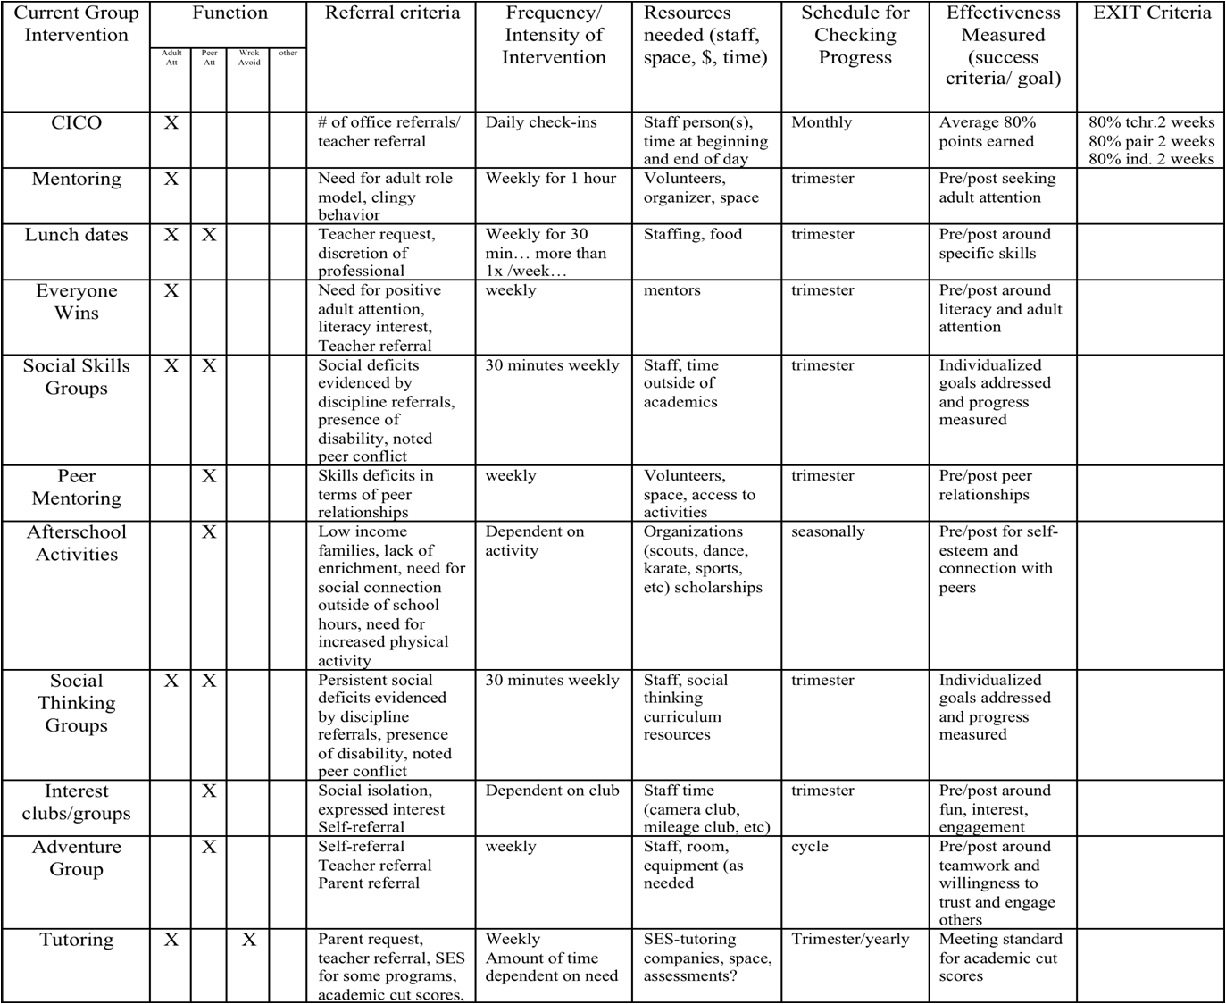

School-wide Behavior Implementation Plan

Behavior Roll-Out for Staff

Date:

Time:

Location:

Materials Required (check or list all that apply):

Agenda ____ Handouts ____ Other _____________________________________

Technology Supports LCD ____ TV/DVD/VIDEO _____ Screen ______ Easel ______ Chart Paper ______ Markers ______ Other _______

Presenters: __________________ ; ___________________ ; ____________________ ;

______________________ ; ________________________; ______________________

Activities (attach work sheets, if needed) Amount of Time

1. ____________

2. ____________

3. ____________

4. ____________

Evaluation/ Feedback Method (check all that apply)

Survey _____ Process Activity _____ Interview ______ Other __ Describe __________

School-wide Behavior Implementation Plan

Behavior Roll-Out for Students

Date:

Time:

Location:

Materials Required (check or list all that apply):

Agenda ____ Handouts ____ Other _____________________________________

Technology Supports LCD ____ TV/DVD/VIDEO _____ Screen ______ Easel ______ Chart Paper ______ Markers ______ Other _______

Presenters: __________________ ; ___________________ ; ____________________ ;

______________________ ; ________________________; ______________________

Activities (attach work sheets, if needed) Amount of Time

1. ____________

2. ____________

3. ____________

4. ____________

Evaluation/ Feedback Method (check all that apply)

Survey _____ Process Activity _____ Interview ______ Other __ Describe __________

School-wide Behavior Implementation Plan

Behavior Roll-Out for Family and Community

Date:

Time:

Location:

Materials Required (check or list all that apply):

Agenda ____ Handouts ____ Other _____________________________________

Technology Supports LCD ____ TV/DVD/VIDEO _____ Screen ______ Easel ______ Chart Paper ______ Markers ______ Other _______

Presenters: __________________ ; ___________________ ; ____________________ ;

______________________ ; ________________________; ______________________

Activities (attach work sheets, if needed) Amount of Time

1. ____________

2. ____________

3. ____________

4. ____________

Evaluation/ Feedback Method (check all that apply)

Survey _____ Process Activity _____ Interview ______ Other __ Describe __________

Examples of Permission Slips:

Example #1:

Winder School
Permission for Check-In/Check-Out
Date ____________________
Student _____________________________________ Grade _______________
Teacher _____________________________________

Parent / Guardian _____________________________

I would like to include your child in our Check-In/Check-Out Program. A report will be filled out daily by the teacher(s) and checked at the end of the day by our coordinator, Mrs. Williams. Students will need to pick up their report every morning between 8:45 and 9:00 a.m. and then return to Mrs. Williams between 3:45 and 4:00 p.m. The student will be able to earn incentives and rewards for appropriate behavior. As parents, you are responsible for making sure your child arrives on time each day for check-in and that you review and sign the daily BEP Report. Together, we can make this a positive experience for your child.

_____ I do give consent for my student to participate.

_____ I do not give consent for my student to participate.

___________________________________ Date _________________________
( Parent / Guardian )

For further information, please call:
___________________________________ at 555-7525,
Sabrina Williams

or call ___________________________________.

Examples of Permission Slips:

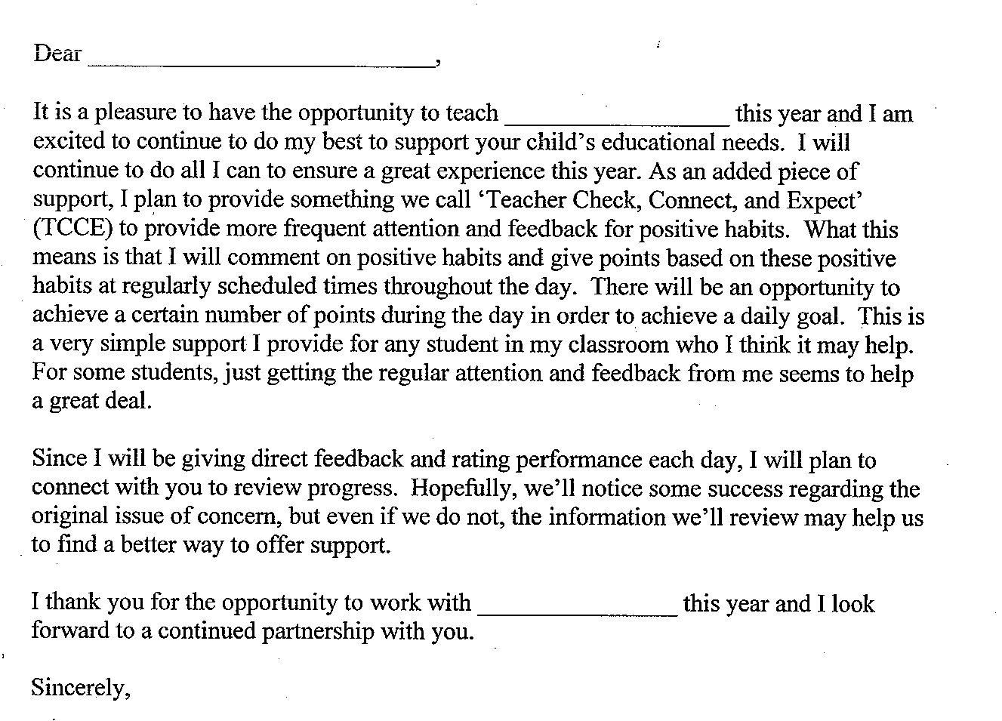
Example #2:

Examples of Daily Progress Reports (DPRs):

PAWS
(Positive Assistance With Support)
Hardwick Elementary School  Daily Progress Report |  |  |  | Name
 |  |  |  | Date |  | Teacher
GOALS | Before School | Practical/Fine Arts | Math |  | Lunch |  | Recess | Literacy
Respect People | 2 1 0 | 2 1 0 | 2 1 0 |  | 2 1 0 |  | 2 1 0 | 2 1 0
Respect Property | 2 1 0 | 2 1 0 | 2 1 0 |  | 2 1 0 |  | 2 1 0 | 2 1 0
Practice Safety | 2 1 0 | 2 1 0 | 2 1 0 |  | 2 1 0 |  | 2 1 0 | 2 1 0
Show Care and Concern | 2 1 0 | 2 1 0 | 2 1 0 |  | 2 1 0 |  | 2 1 0 | 2 1 0
Adult Initial
Total
Points

Total Possible: 48 Goal for Today: __________
Key
0 = Keep trying.
1 = Almost there . . .
2 = Great!!

Total for Today: __________ % _______

Parent Signature: _________________________________

Examples of Daily Progress Reports (DPRs):

Check In /Check Out Card (CICO)

Student_____________________________________________________________ Date________________

KEY: | 0 = Try again | 1 = Needs work | 2 = Got It!

EXPECTATION | SAFE | RESPECTFUL | READY to LEARN
 | Keeping hands, feet, other objects to self | Using kind words, actions, following directions | Working carefully, doing your best,  be prepared
Math | 0 1 2 | 0 1 2 | 0 1 2
Reading/Language | 0 1 2 | 0 1 2 | 0 1 2
AM Recess | 0 1 2 | 0 1 2 | 0 1 2
Lunch | 0 1 2 | 0 1 2 | 0 1 2
PM Recess | 0 1 2 | 0 1 2 | 0 1 2
Theme, Social Studies, Science | 0 1 2 | 0 1 2 | 0 1 2
Art/PE/Music | 0 1 2 | 0 1 2 | 0 1 2
Library/Tech/Choice/Other | 0 1 2 | 0 1 2 | 0 1 2
SUBTOTAL

# ___________ points received
# __________ points possible
% __________ of points

WOW ! Comments: _______________________________________________________________________________________________________________________________

Parent/Guardian Signature____________________________________________________

CICO monitor Initials_________
Examples of Daily Progress Reports (DPRs):

P.A.W.S. PLAN
Positive Assistance With Support
Woodbury Bears are Responsible, Respectful & Safe

Date______________________ Student______________________________

0= Keep Trying  1= Almost There  2= You Did It! | Responsible  Follow Directions  Be Prepared | Respectful  Use Kind Words & Actions  Be Helpful | Safe  Keep Hands, Feet and Objects to Self | Staff Initials
Arrival & Morning Meeting | 0 1 2 | 0 1 2 | 0 1 2
Morning Class Time | 0 1 2 | 0 1 2 | 0 1 2
Lunch | 0 1 2 | 0 1 2 | 0 1 2
Recess | 0 1 2 | 0 1 2 | 0 1 2
Special | 0 1 2 | 0 1 2 | 0 1 2
Afternoon Class Time | 0 1 2 | 0 1 2 | 0 1 2
Dismissal | 0 1 2 | 0 1 2 | 0 1 2
Total Points = _______  Possible Points = 42  Goal (80%) = 34 | Today __________%  Goal __________%

Successes:________________________________________________________________________________________________________
Parent Signature____________________________________________________

