VTPBiS State Approved Coaches
2016-2017

Kym Asam, LICSW
Kym Asam is an Implementation Coach and Trainer for Vermont PBIS. She is the Regional Director of Schools and Clinical Programming for NFI Vermont. She has practiced since 1992 and in addition to direct work with clients, providing clinical supervision to multiple staff and consultation to schools on complicated emotional/behavioral student needs, Kym has conducted numerous trainings for school personnel, both in Vermont and out of state. She is designated as a lead ARC (Attachment, Self-Regulation and Competency) trainer for the state of Vermont and is in the process of being certified in the Neuro-Sequential Model of Therapeutics (NMT) and has extensive training in multiple, evidence-based methods for working with and treating children and adults who have experienced developmental trauma.
Areas of Expertise:
Developmental Trauma, clinical programming for schools, training and consultation on multiple clinical topics, PBIS coaching and training
Preferred Regions: Champlain, Northeast, Lamoille
Contact Information:
Phone: 802.343.3511
E-mail: kymasam@nafi.com

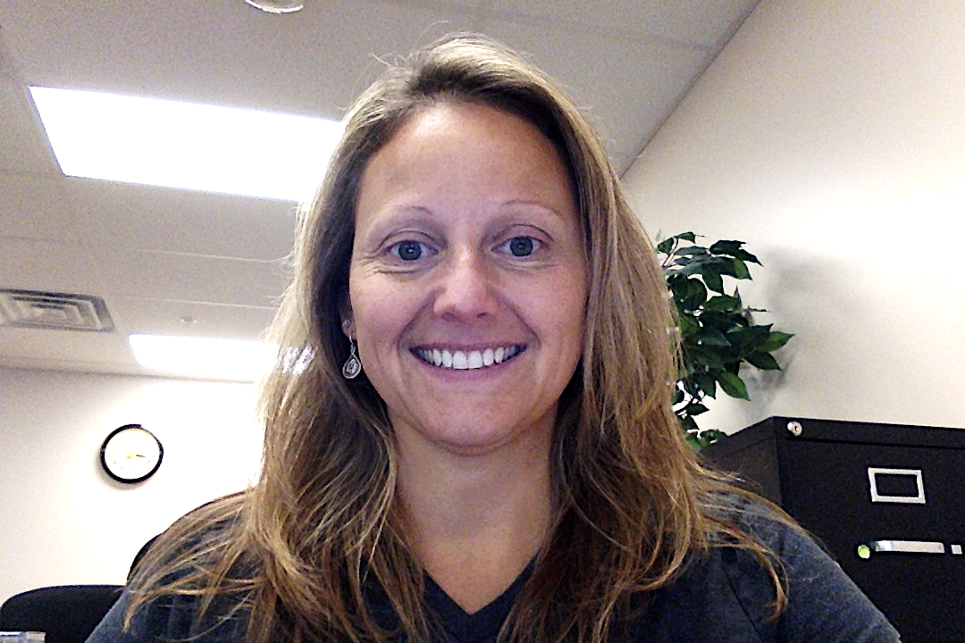 | Kristin Beswick
 | Kristin Beswick is an Implementation Coach and Trainer for Vermont PBIS. She is a licensed School Psychologist and has been working in the NEK as a Behavior Specialist in schools for 13 years. Prior to Vermont, she worked for 7 years as a School Psychologist in NY, Illinois, Iowa and Arizona. She has been a PBIS Coach for 3 years and provided Universal Training to new schools embarking on PBIS.
Areas of Expertise:
Systems of Support, Challenging Behavior, Executive Functioning, Behavior Planning, Child Development, Staff Training
 | Preferred Regions: Northeast, Champlain
Contact Information:
Phone: 602-316-2426 (cell)
E-mail: Kristin.beswick@ncsuvt.org

Teri Brooks, Ph.D, BCBA
Teri is an Implementation Coach and Trainer for Vermont PBIS. She is a doctoral-level school psychologist as well as a Board-Certified Behavior Analyst (BCBA). She has been working with families and schools to find solutions to support students with challenging behavior since 1993. Teri is in private practice providing behavior therapy, school consultation, evaluation services, and PBIS coaching. She is a dynamic presenter who enjoys engaging others in passionate pursuit of making things better for children, their families, and their school communities.
Areas of Expertise: CPI, FBA, BSP, Intensive-Level PBIS, Behavior Consulting, Staff Training
Preferred Regions: Southwest and Southeast
Contact Information:
Phone: 802-380-1713
E-mail: terimbrooks@gmail.com
Website: : www.behaviorsolutionsvt.com

Nicole Grenier, MHA
Nicole is an Implementation Coach and Trainer for Vermont PBIS. She holds a Master's Degree of Health Care Administration from the University of Scranton and has served as a mental health professional with 18+ years experience in a variety of roles serving children, youth and families while collaborating with school teams and the local systems of care in Pennsylvania, New Jersey and Vermont. She’s also the owner of the Stowe Street Cafe in Waterbury where she continues her commitment to building community and advocating for issues affecting Vermont children and families. In addition to her work with PBIS, also provides training in the Strengthening Families model within the Early Childhood community.
Areas of Expertise: Child Development, Families & Communities, Professionalism & Program Organization, Brain Development, Social/Emotional Development, Building Relationships with Families, Family Systems, Respectful Communication, Parenting, Parent Involvement, Community Resources, Networking and Collaborations, Home Visiting, Systems Resources, Working with Staff and Colleagues, How Adults Learn, Program Administration, Leadership
Preferred Regions: Lamoille
Contact Information:
Phone: (802) 793-9869
E-mail: nicole.grenier12@gmail.com

Jean C. Haigh, M.Ed.
Jean is an Implementation Coach and Trainer for Vermont PBIS. She has over 40 year of experience in public education, serving individuals with disabilities. She has a strong background in adult learning, collaborative leadership, program & professional development and systems design & review.
Areas of Expertise: Special Education, Differentiated Instruction, General Education, ABA, Data Analysis, Evidence-Based Practices, Trainer and External Coach in all aspects of VTPBiS.
Preferred Regions: Northeast, Lamoille and Champlain
Contact Information:
Phone: 802-586-9637
Cell: 802-586-9637
E-mail: jhaighvt@gmail.com

Cortney Keene, M.Ed, CAS, BCBA
Cortney is an Implementation Coach and Trainer for Vermont PBIS. She has 11 years of experience in Vermont Special education, working in the Hartford School District, primarily with students with emotional and behavior needs, intensive special needs, and autism spectrum disorders as a special education teacher, behavior specialist, and special education technology integrationist. She is also an FBA trainer and Board Certified Behavior Analyst. Additionally, she works part-time for the Vermont ITEAM as an Educational and Behavior Consultant. Cortney has her Associates from Simon's Rock College of Bard, BA from UVM in Psychology, M.Ed. from Antioch New England in Place-Based and Environmental Education, and CAS in Emotional/Behavioral Disturbances from UVM.
Areas of Expertise: Behavior Analysis, FBA/BSP, PBIS Systems, Special Education
Preferred Regions: Southeast and Southwest
Contact Information:
Phone: 802.380.2951
E-mail: Cortney.keene@uvm.edu

Jeremy Tretiak
Jeremy Tretiak is an Implementation Coach and Trainer for Vermont PBIS. He has been working in the field for 9 years, during which he has been a classroom teacher and worked in both direct service and consultation roles with children, families, and schools. Jeremy earned his BS from St. Lawrence University and an MA in Education from Johnson State College. He has been a Board Certified Behavior Analyst since 2015 and is also a Licensed Behavior Analyst in Vermont. He has extensive experience training and supporting school staff in the theory and implementation of principles and practices of Applied Behavior Analysis and PBIS.
Areas of Expertise: Applied Behavior Analysis, FBA/BSP, PBIS Systems
Preferred Regions: Central & Champlain
Contact Information:
Phone: 203-910-4088
E-mail: jeremytretiakgmbc@gmail.com

Jon Kidde
Jon Kidde has been exploring the concepts of restorative justice (RJ) for 20 years and has played a critical role in the conceptualization, application, and enhancement of restorative justice within different contexts—education, justice, and within organizations in several states. Jon is currently an independent consultant focused on restorative justice and school discipline & juvenile justice reform living in Vermont. Jon received an MSW degree from the School of Social Welfare at University of California – Berkeley. He co-authored Restorative Justice: A Working Guide for Our Schools with Rita Alfred during the initial implementation of RJ within Oakland Unified School District. He is a Certified Dialogue Education Teacher.

Areas of Expertise: Whole-School Restorative Justice
Preferred Regions: Champlain, statewide
Contact Information:
Phone: 802.349.3317
E-mail: jonkidde@greenomegal3c.org

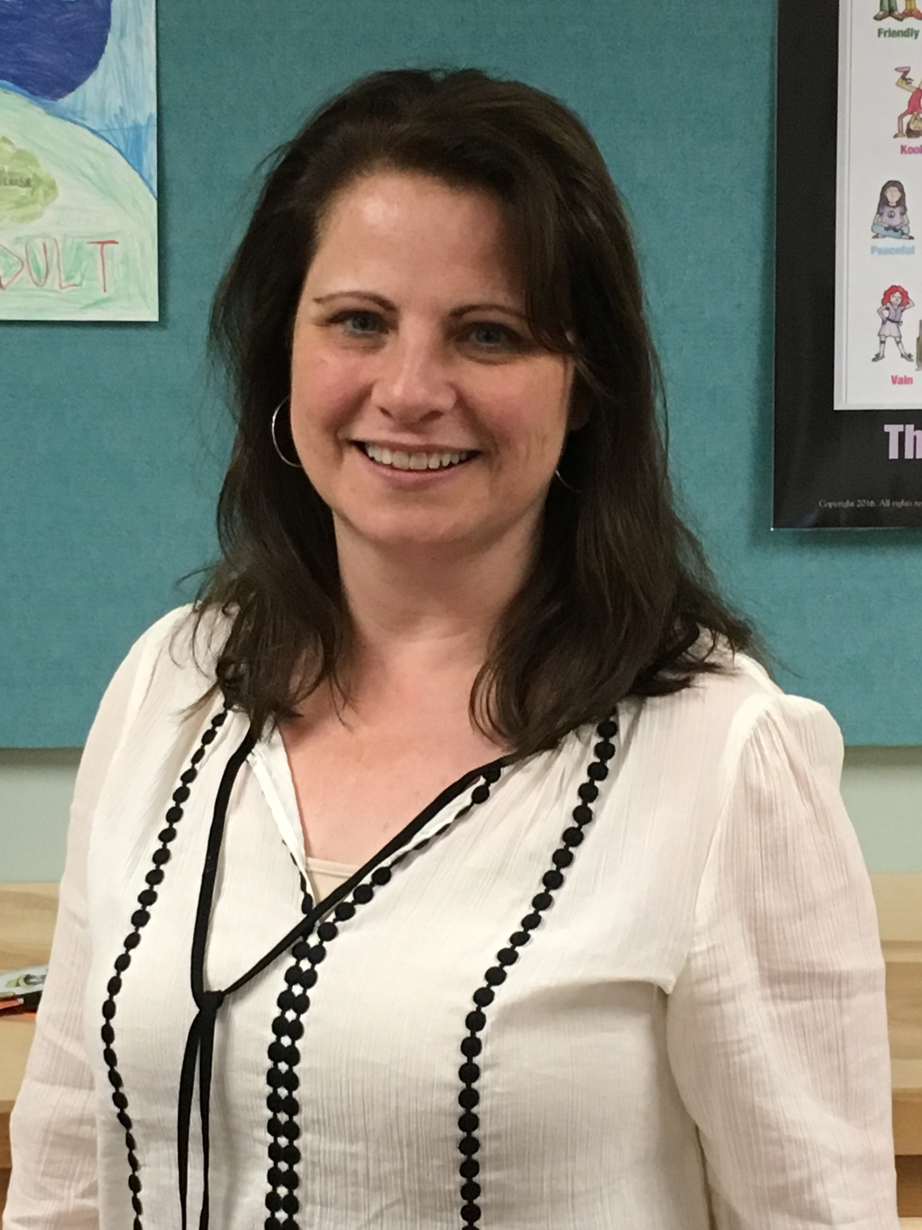 | Rebecca Lallier, M.Ed.
 | Rebecca Lallier is an Implementation Coach and Trainer for Vermont PBIS. She has 20 years of experience as a school counselor at the Dothan Brook School, where she has been the PBIS coach and coordinator since DBS adopted PBIS in 2009. Dothan Brook implements PBIS at all three tiers and has been named a VTPBIS Exemplar School since 2011.
 | Areas of Expertise: PBIS implementation at all tiers; implementation fidelity, revitalization, and improvement; staff buy-in; SWIS; classroom management; trauma-informed practice; Social Skills instruction within MTSS; Second Step
 | Preferred Regions: Southeast, Northeast, Lamoille
Contact Information:
Phone: 802-558-8791
Email: rebecca.lallier@gmail.com

Bonnie Poe
Bonnie is an Implementation Coach and Trainer for Vermont PBIS. Her undergraduate and graduate degrees are in special education from Georgia State University. She has 40 plus years of experience in public education, including 18 years as a school principal (she was a Vermont middle school principal of the year) and 7 years as a director of student support services. Bonnie has worked as a SWIFT LEA Facilitator and has received additional training in mentoring, instructional coaching, and the 4 stages of the change process. She is a positive coach and resource who builds trusting relationships with all members of the school community.

Areas of Expertise: Assisting schools in developing systems for building capacity and sustainability of PBIS efforts, guiding schools in the stages of change, providing training in instructional coaching using the Jim Knight model, using data to make and support decisions, providing resources, MTSS, collaborative leadership, staff training, and special education.
Preferred Regions: Northwest, Champlain Valley, Central Vermont, and open
Contact Information:
Phone: (802) 316-6190
E-mail: bonnie_poe@comcast.net

Melissa Tappin
Melissa Tappin is an Implementation Coach for Vermont PBIS. Her background work is in psychology and Autism, with Master’s level work in Applied Behavioral Analysis. She has worked with students with ASD, PDD and other behavioral needs, their families and school personal in the home, school and community settings. She has been a Behavior Specialist for the past 7 years, specializing in FBA’s, Behavioral and data Analysis and PBIS implementation. She has also been a Handle With Care trainer. Melissa finds her best work is done in collaboration with other people – and always seeks to incorporate information from all involved. She focuses on showing the strengths and needs of individuals, groups and school systems through data analysis with graphs, tables and charts, using Excel, SWIS and other apps.
Areas of Expertise: Applies Behavioral Analysis, behavior modification, Functional Behavior Assessments, behavior support plans, data analysis, PBIS, SWIS, HWC, trauma training, autism, communication systems
Preferred Regions: Lamoille, most of: Champlain, Northeast, and Southeast
Contact Information:
Phone: 802.318-0843
E-mail: melissartappin@gmail.com

