VTPBIS State-Approved Coaches
2021-2022

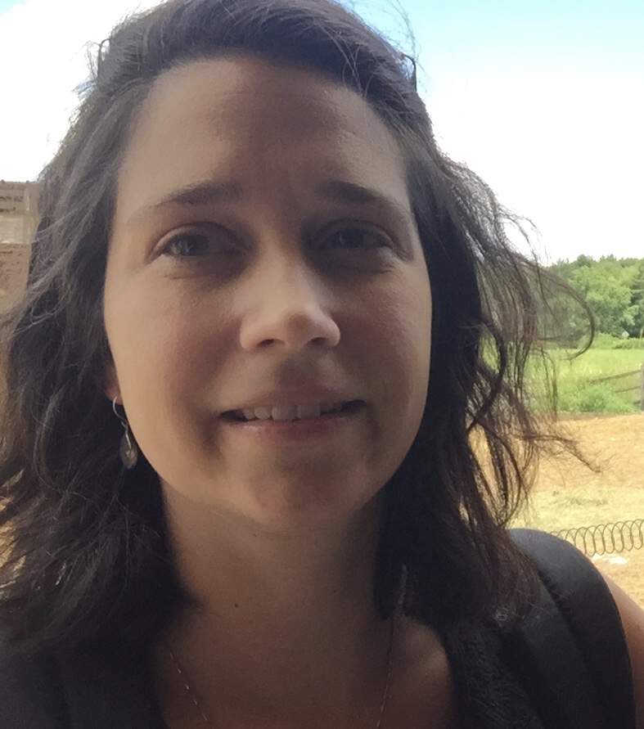 | Chantelle Albin
 | Chantelle Albin is an Implementation Coach and Trainer for Vermont PBIS. She is a school counselor for a pre-k - 6th grade elementary school. She has a Masters in Education with a school counseling endorsement and has been working with children ages 5-17 for the last 15 years in residential and public school settings. Chantelle has a passion for assisting schools in developing the PBIS framework with fidelity and in using data to make and support decisions. She enjoys supporting schools with Universal level implementation, including the creation of school wide expectations, school wide acknowledgements/celebrations, teaching expectations, creating PBIS leadership team agendas, and supporting PBIS school-based coordinators.
Areas of Expertise:
Systems of Support, Challenging Behavior, Behavior Planning, PBIS implementation at tier 1, implementation fidelity, SWIS, classroom management; trauma-informed practice, Social Skills instruction with Second Step.
 | Preferred Regions: Southern VT
Contact Information:
Phone: 802.258.8978
E-mail: chanlalbin@gmail.com

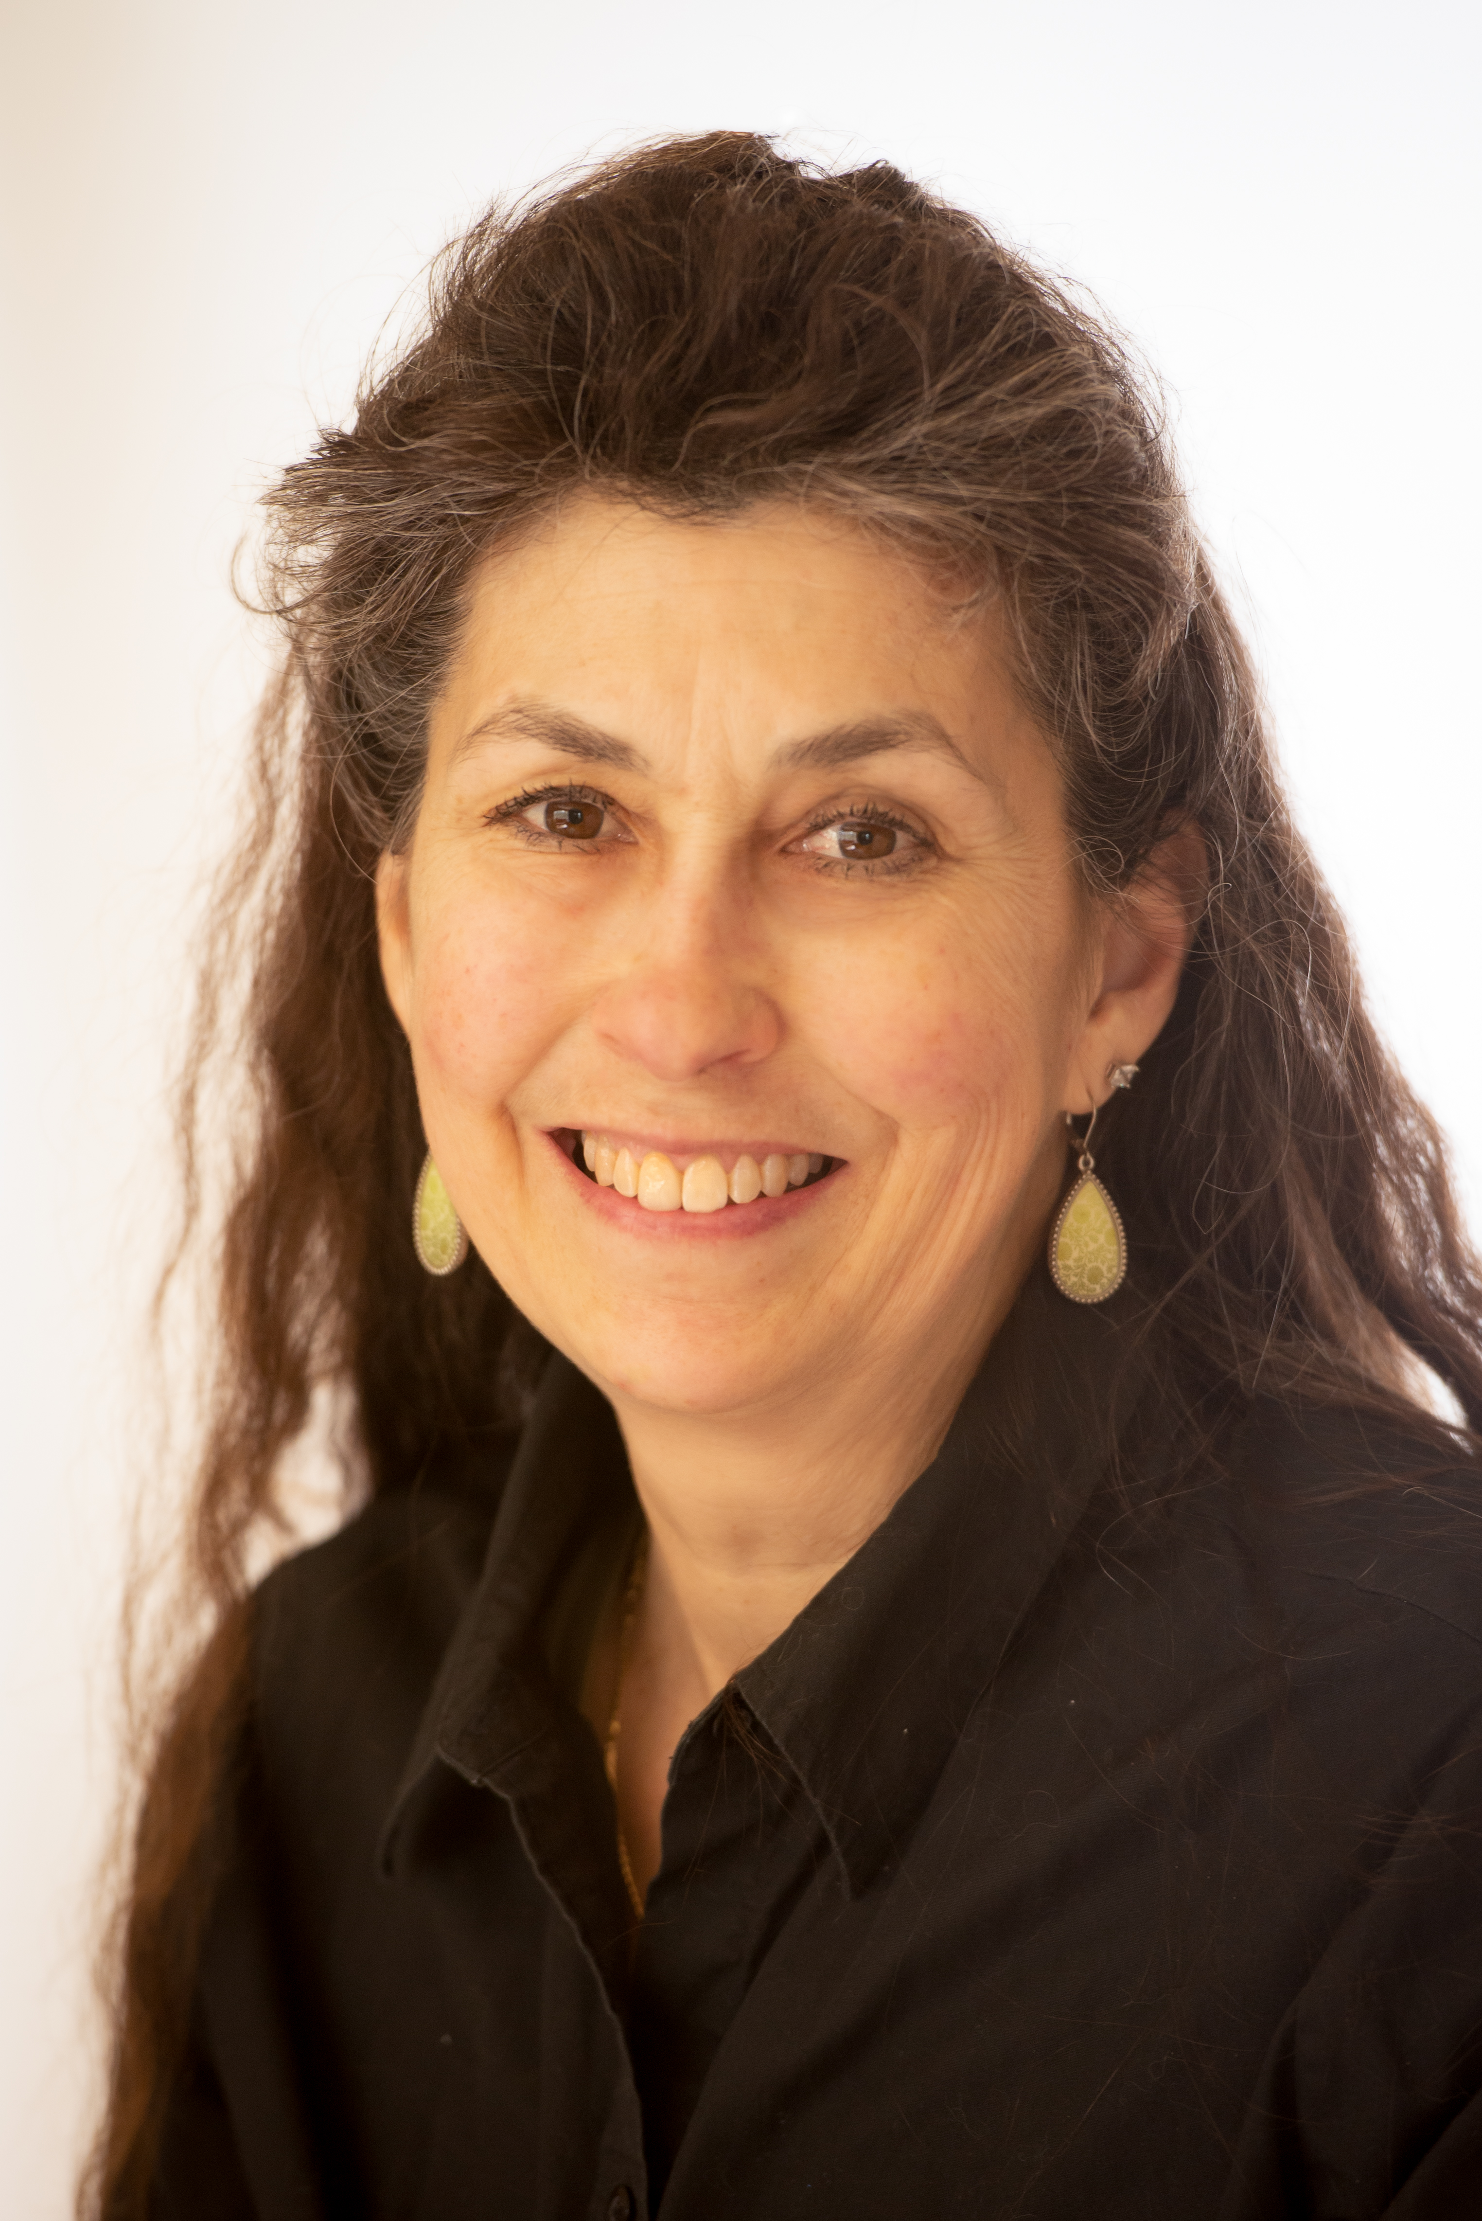 | Kym Asam, LICSW
 | Kym Asam is an Implementation Coach and Trainer for Vermont PBIS. She is the Regional Director of Schools and Clinical Programming for NFI Vermont. She has practiced as a licensed independent clinical social worker since 1992 and in addition to direct work with clients, providing clinical supervision to multiple staff and consultation to schools on complicated emotional/behavioral student needs, Kym has conducted numerous trainings for school personnel, both in and out of the state of Vermont. She is designated as an ARC (Attachment, Self-Regulation and Competency) trainer for the state of Vermont and works with multiple SU’s and districts on developing trauma-responsive practices, policies and procedures. She is in the process of being certified in the Neuro-Sequential Model of Therapeutics (NMT) and has extensive training in multiple, evidence-based methods for working with and treating children and adults who have experienced developmental trauma.
Areas of Expertise:
Developmental Trauma, clinical programming for schools, training and consultation on multiple clinical topics, PBIS coaching and training
 | Preferred Regions: Champlain, Northeast, Lamoille
Contact Information:
Phone: 802.343.3511
E-mail: kymasam@nafi.com

Amanda Babcock
Amanda Babcock is a new Implementation Coach and Trainer for Vermont PBIS. She has been in the education field for 22 years working as a Special Educator and Behavior Coach at the elementary school level. She is currently the Behavior Coach and coordinator of JFK's SSR (Student Support Room), supporting students as well as staff alongside her team of three SSR BI's. As a Behavior Coach, she has advocated for and supported some of the most challenging students to become successful by coordinating with teams to complete simple Functional Behavioral Assessments (FBAs), Behavior Support Plans (BSPs), and Crisis Plans. Amanda has been a PBIS School Coordinator since 2007, helping both Swanton Elementary and JFK Elementary on their journey with PBIS implementation and practices. Amanda have been trained as a facilitator in SWIS and has experience using SWIS, SWIS-CICO, and I-SWIS. She has also been trained in/taken course work in trauma-informed practices, CPI, LSCI, Classroom Behavior Practice Coaching, and Ross Greene's work of Collaborative Problem Solving.

Areas of Expertise: SWIS, SWIS-CICO, I-SWIS, PBIS implementation, FBA/BSP, writing Crisis Plans, using various data sources to make support and planning decisions
Preferred Regions: Northwest Vermont (Franklin County and Grand Isle), Chittenden County
Contact Information:
Phone: 802.383.6060
Work Cell: 802.316.7106
E-mail: ababcock@wsdvt.org

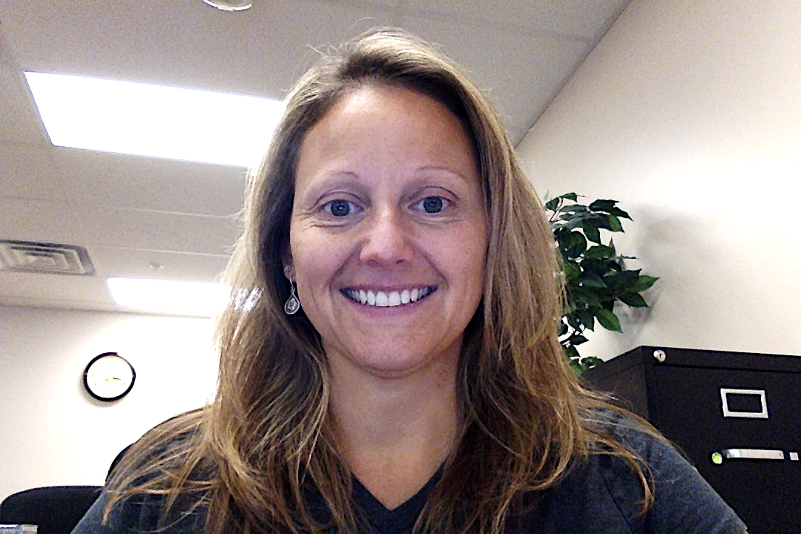 | Kristin Beswick
 | Kristin Beswick has worked as an Implementation Coach and Trainer for Vermont PBIS for 8 years. She has worked in the NEK as a Behavior Specialist for 18 years. Prior to Vermont, she worked as a School Psychologist conducting evaluations, supporting school teams and consulting with administrators. She has provided Universal, Targeted and Refresher Trainings to school leadership teams.
Areas of Expertise:
Systems of Support, Challenging Behavior, Executive Functioning, Behavior Planning, Child Development, Staff Training
 | Preferred Regions: Northeast, Champlain
Contact Information:
Phone: 602-316-2426 (cell)
E-mail: Kristin.beswick@ncsuvt.org

Laura Ellis
Laura Ellis is a Nationally Certified School Psychologist and has worked at J. J. Flynn Elementary School in Burlington School District over the past four years. In that role, she served as the Chair of their PBIS Committee and collaborated to create a Social Emotional Learning Committee, which comprises their PBIS and Restorative Practices Committees. Prior to working at J. J. Flynn Elementary School, Laura worked as the Behavior Specialist and School Psychologist for Chittenden East Supervisory Union for four years, working at three elementary schools and the high school. She completed her school psychology internship in Burlington School District and assisted staff with creating the alternative elementary school program (formerly known as the ABC Program) during its first year of implementation in the Burlington School District. Laura was previously a behavior specialist and teacher consultant for four years for several inner-city public schools in the Buffalo, NY area. She has a strong background as a research assistant through her work for the University at Buffalo’s Center for Children and Families while completing her Master’s degree there. She recently became a 200-hour certified yoga and meditation teacher through Laughing River Yoga studio. Laura brings a wealth of knowledge to educators, staff, and families on best strategies and practices working with children who have experienced trauma and she has a considerable background in behavior management strategies and Positive Behavioral Interventions and Supports. Laura has experience utilizing the SWIS data system, as well as analyzing and interpreting data for data-based decision making. Laura is currently employed by the Essex Community Justice Center. Laura's role at the Essex Community Justice Center includes providing professional development training to teaching staff around restorative practices and also facilitating trainings for students to be leaders for restorative approaches in their schools.
Areas of Expertise: SWIS, PBIS implementation, FBA/BSP, analyzing evaluation results to determine best matched interventions, trauma-informed interventions and best practices, restorative practices, yoga and mindfulness for classrooms, implementation of social-emotional learning programs.
Preferred Regions: Northwest Vermont (Franklin County and Grand Isle), Lamoille County, Chittenden County, Champlain
Contact Information:
Phone: 518.335.9785
E-mail: lestraub@buffalo.edu

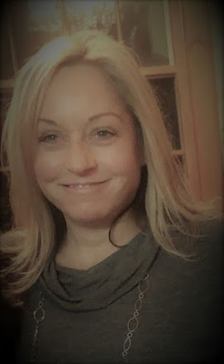 | Lauralee Keach, M.Ed
 | Lauralee has been working with children with a range of needs, including developmental disabilities and autism spectrum disorder, for the past 20 years. She received her initial training in behavior analysis in Maine, where she was a member of a team who established a center-based program for students with developmental disabilities and emotional and behavior disorders. Since returning to Vermont in 2003, Lauralee has worked as a Board Certified Behavior Analyst consulting to regional school districts, and currently is a member of the South Burlington School District’s Interdisciplinary Team, which provides behavior, psychological and communication consultation services to students and school teams. Lauralee’s education includes a BA in Psychology and a M.Ed in Applied Behavior Analysis.
 | Areas of Expertise: Applied Behavior Analysis, FBA/BSP, PBIS systems, Data analysis, Staff training
 | Preferred Regions: Champlain, Addison, Lamoille
Contact Information:
Phone: 802-652-7147
E-mail: lkeach@sbschools.net

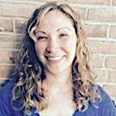 | Cortney Keene, M.Ed, CAS, BCBA
 | Cortney Keene has been working with children with a variety of needs including autism spectrum disorder, ADHD, Down Syndrome, Emotional and Behavioral Disorders, and others since 2005. Over the past 12 years, Cortney has worked in a variety of roles: special education teacher, special education technology integrationist, and as coordinator of an elementary autism program. Currently, Cortney is co-owner and Clinical Director of Keene Perspectives, a center-based ABA therapy clinic in White River Junction that she and her husband, Chris Keene, opened in January of 2018. She also works with two projects through the Center on Disability and Community Inclusion (CDCI) at the University of Vermont: as a coach and trainer for Vermont Positive Behavioral Intervention and Supports (VTPBIS) helping school teams implement the PBIS framework, and as a statewide behavior consultant for the Vermont I-TEAM providing support to teams who work with students with low incidence disabilities and complex support needs. She holds a BA in Psychology, an M.Ed. in Place-based and Environmental Education, and received a Certificate of Graduate Study (CAGS) in Emotional/Behavioral Disturbances. Cortney is also a Board Certified Behavior Analyst (BCBA) and Vermont Licensed Behavior Analyst (VT-LBA).
 | Areas of Expertise: Behavior Analysis, FBA/BSP, PBIS Systems, Special Education
 | Preferred Regions: Southeast and Southwest
Contact Information:
Phone: 802.380.2951
E-mail: Cortney.keene@uvm.edu

Jon Kidde, MSW
Jon Kidde has been exploring the concepts of restorative justice (RJ) for 20 years and has played a critical role in the conceptualization, application, and enhancement of restorative justice within different contexts—education, justice, and within organizations in several states. Jon is currently an independent consultant focused on restorative justice and school discipline & juvenile justice reform living in Vermont. Jon received an MSW degree from the School of Social Welfare at University of California – Berkeley. He co-authored Restorative Justice: A Working Guide for Our Schools with Rita Alfred during the initial implementation of RJ within Oakland Unified School District. He is a Certified Dialogue Education Teacher.
Areas of Expertise: Whole-School Restorative Justice
Preferred Regions: Champlain, statewide
Contact Information:
Phone: 802.349.3317
E-mail: jonkidde@greenomegal3c.org

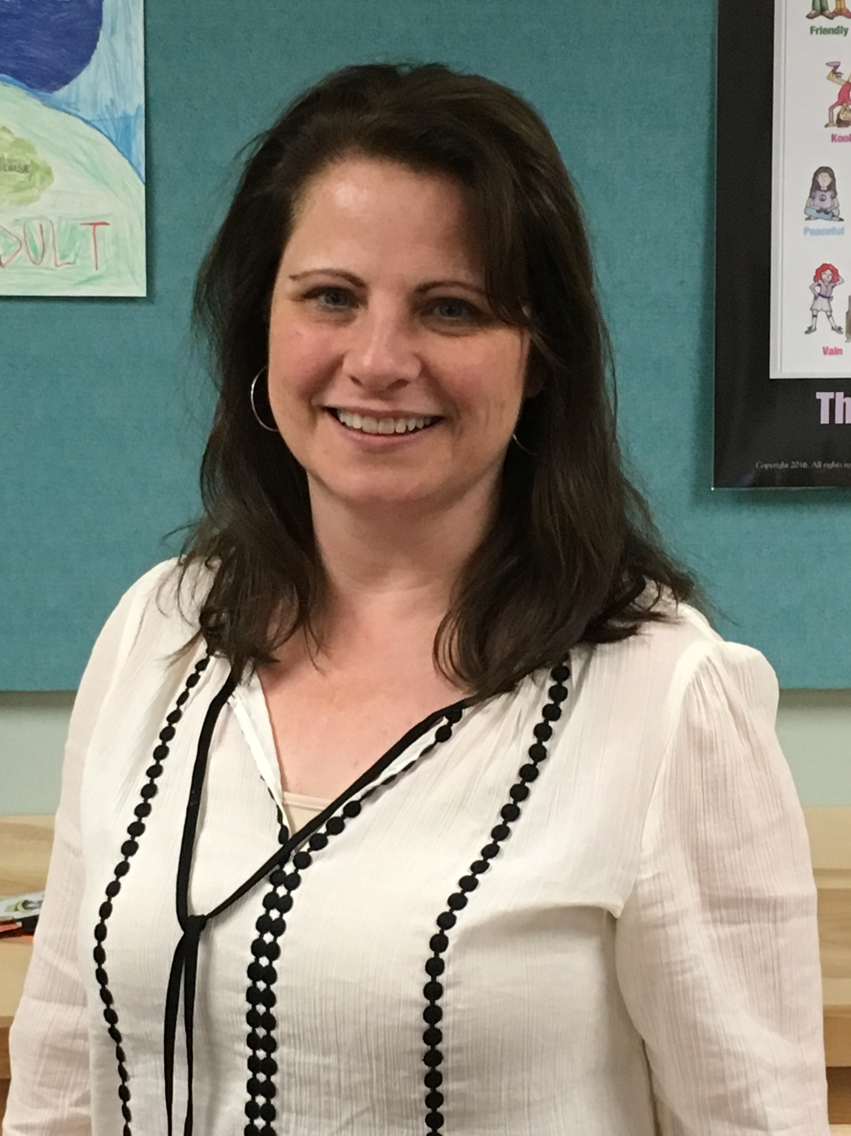 | Rebecca Lallier, M.Ed.
 | Rebecca Lallier, M.Ed. is a TA, Implementation Coach, and Trainer for Vermont PBIS. She spent 11 years as PBIS coordinator at the Dothan Brook School, a nine-year exemplar school, navigating all aspects of PBIS from initial implementation through revitalization, full implementation at all three tiers, and continuous improvement. Rebecca has 23 years of experience as a school counselor and was the 2016 Vermont School Counselor of the Year and a 2017 National ASCA School Counselor of the Year finalist. She is passionate about the importance of building trust and relationships while helping schools and teams center equity for all students, build on strengths, and solve problems to increase fidelity of PBIS implementation. Rebecca is especially interested in how PBIS, SEL, adult resilience, and positive school climate support and strengthen one another.
 | Areas of Expertise: PBIS implementation at all tiers; implementation fidelity, revitalization, and improvement; staff buy-in; SWIS; classroom management; trauma-informed practice; Social Skills instruction within MTSS; Second Step
 | Preferred Regions: Southeast, Northeast, Lamoille
Contact Information:
Phone: 802-558-8791
Email: rebecca.lallier@gmail.com

Bonnie Poe
Bonnie is an Implementation Coach and Trainer for Vermont PBIS. Her undergraduate and graduate degrees are in special education from Georgia State University. She has 40 plus years of experience in public education, including 18 years as a school principal (she was a Vermont middle school principal of the year) and 7 years as a director of student support services. Bonnie has worked as a SWIFT LEA Facilitator and has received additional training in mentoring, instructional coaching, and the 4 stages of the change process. She is a positive coach and resource who builds trusting relationships with all members of the school community.
Areas of Expertise: Assisting schools in developing systems for building capacity and sustainability of PBIS efforts, guiding schools in the stages of change, providing training in instructional coaching using the Jim Knight model, using data to make and support decisions, providing resources, MTSS, collaborative leadership, staff training, and special education.
Preferred Regions: Northwest, Champlain Valley, Central Vermont, and open
Contact Information:
Phone: (802) 316-6190
E-mail: bonnie_poe@comcast.net

Jeremy Tretiak, MA
Jeremy Tretiak is an Implementation Coach and Trainer for Vermont PBIS. He has been working in the field for 12 years, during which he has been a classroom teacher and worked in both direct service and consultation roles with children, families, and schools. Jeremy earned his BS from St. Lawrence University and an MA in Education from Johnson State College. He has been a Board Certified Behavior Analyst (BCBA) since 2015 and is also a Licensed Behavior Analyst in Vermont. He has extensive experience training and supporting school staff in the theory and implementation of principles and practices of Applied Behavior Analysis and PBIS. He is also a certified instructor for Crisis Prevention Intervention (CPI), with a trauma endorsement.
Areas of Expertise: Applied Behavior Analysis, FBA/BSP, PBIS Systems, CPI (Non-violent crisis intervention)
Preferred Regions: Central & Champlain
Contact Information:
Phone: 203-910-4088
E-mail: jeremy@gmbehavior.org

