Resources From Dr. Rosemarie Allen’s Keynote

Note: While these books can be found at many different websites/libraries, etc., the links provided below are to online shops for Black-owned bookstores, several of which have curated lists of other anti-bias/anti-racism books if you are interested in finding more resources.

- Don’t Look Away: Embracing ANTI-BIAS Classrooms
by Iheoma Iruka, Stephanie Curenton, Tonia Durden, and Kerry-Ann Escayg

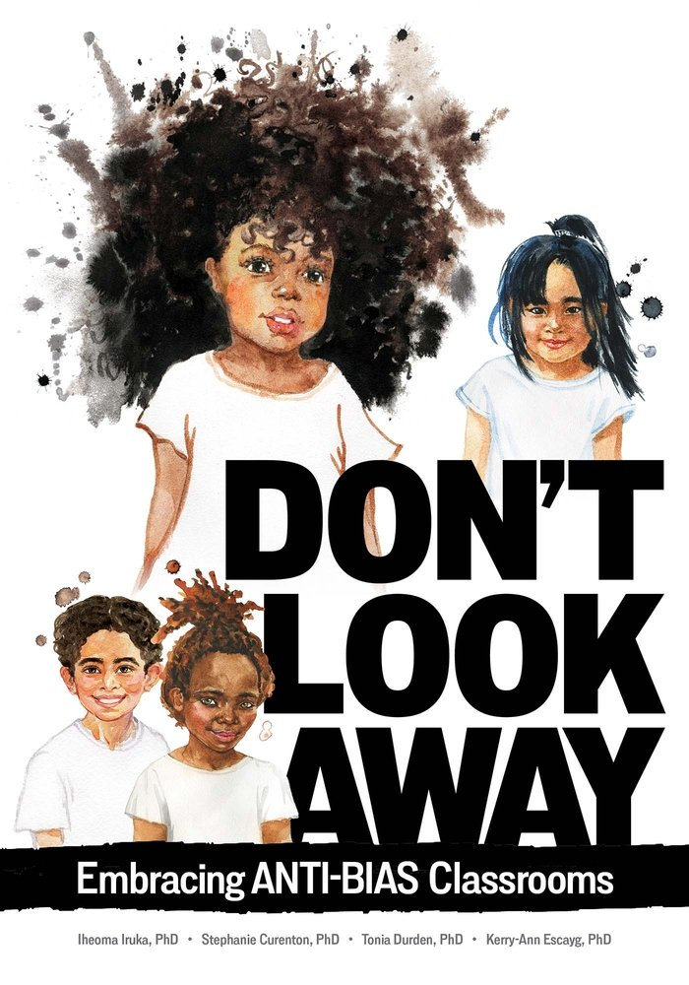
Link: https://bookshop.org/books/don-t-look-away-embracing-anti-bias-classrooms/9780876598436

- How To Be An Antiracist by Abram X. Kendi

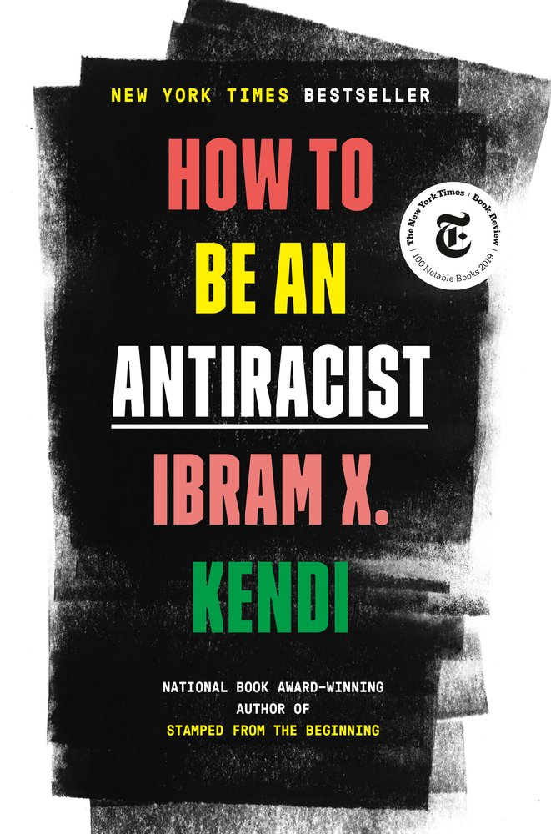

Description (from link below): “Antiracism is a transformative concept that reorients and reenergizes the conversation about racism--and, even more fundamentally, points us toward liberating new ways of thinking about ourselves and each other. At its core, racism is a powerful system that creates false hierarchies of human value; its warped logic extends beyond race, from the way we regard people of different ethnicities or skin colors to the way we treat people of different sexes, gender identities, and body types. Racism intersects with class and culture and geography and even changes the way we see and value ourselves. In How to Be an Antiracist, Kendi takes readers through a widening circle of antiracist ideas--from the most basic concepts to visionary possibilities--that will help readers see all forms of racism clearly, understand their poisonous consequences, and work to oppose them in our systems and in ourselves.
Kendi weaves an electrifying combination of ethics, history, law, and science with his own personal story of awakening to antiracism. This is an essential work for anyone who wants to go beyond the awareness of racism to the next step: contributing to the formation of a just and equitable society.”
Link: https://bookshop.org/books/how-to-be-an-antiracist/9780525509288

- The Warmth of Other Suns: The Epic Story of America’s Great Migration by Isabel Wilkerson

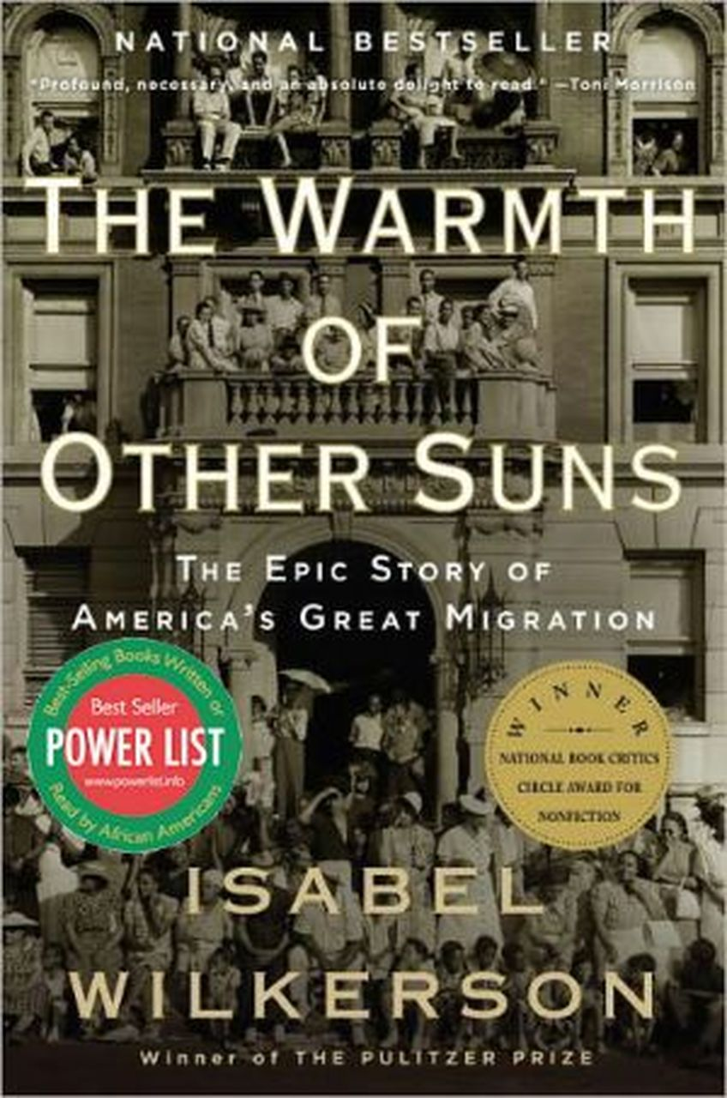

Description (brief; from link below): “In this epic, beautifully written masterwork, Pulitzer Prize–winning author Isabel Wilkerson chronicles one of the great untold stories of American history: the decades-long migration of black citizens who fled the South for northern and western cities, in search of a better life.”
Link: https://www.mahoganybooks.com/9780679763888

- Waking up White, and Finding Myself in the Story of Race by Debby Irving
Description (from link below): “For twenty-five years, Debby Irving sensed inexplicable racial tensions in her personal and professional relationships. As a colleague and neighbor, she worried about offending people she dearly wanted to befriend. As an arts administrator, she didn't understand why her diversity efforts lacked traction. As a teacher, she found her best efforts to reach out to students and families of color left her wondering what she was missing. Then, in 2009, one "aha!" moment launched an adventure of discovery and insight that drastically shifted her worldview and upended her life plan. In Waking Up White, Irving tells her often cringe-worthy story with such openness that readers will turn every page rooting for her-and ultimately for all of us.”
Link: https://bookshop.org/books/waking-up-white-and-finding-myself-in-the-story-of-race/9780991331307

- Ted Talk: Danger of a Single Story by Chimamanda Ngozi Adichie
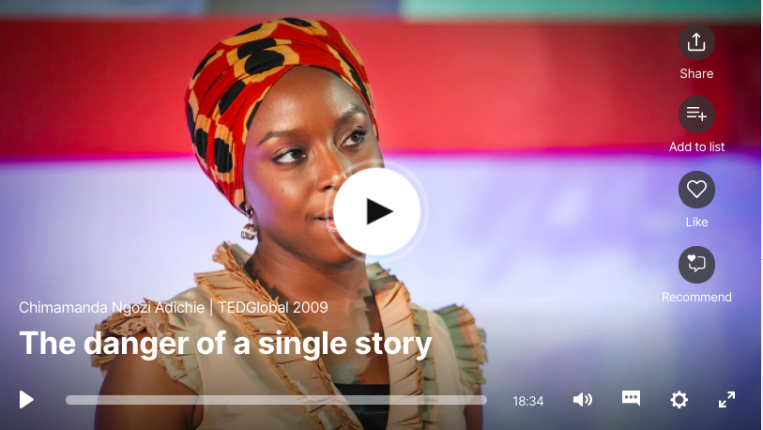
Description (from Ted Talk website): “Our lives, our cultures, are composed of many overlapping stories. Novelist Chimamanda Adichie tells the story of how she found her authentic cultural voice -- and warns that if we hear only a single story about another person or country, we risk a critical misunderstanding.”
Link:https://www.ted.com/talks/chimamanda_ngozi_adichie_the_danger_of_a_single_story?language=en

- The National Center for Pyramid Model Innovations (NCPMI) Resource Library
Description: resources including videos/webinars
Link: https://challengingbehavior.cbcs.usf.edu/resources/index.html

- Rosemarie Allen’s website
Link: http://www.rosemarieallen.com/home.html

