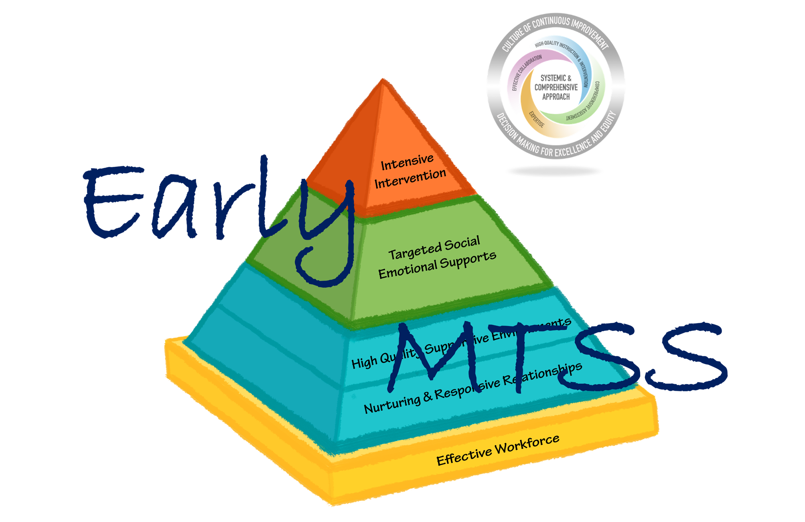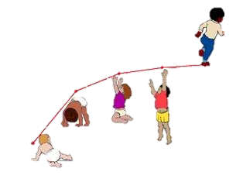

**Dr. Lori Erbrederis Meyer**

University of Vermont

[**lori.meyer@uvm.edu**](mailto:lori.meyer@uvm.edu?subject=Vermont%20Early%20MTSS%20-%20Best%20Institute)

**Julie Lavine**

Director, OCSU Early Childhood Program

Barton, VT

[jlavine@ocsu.org](mailto:jlavine@ocsu.org?subject=Vermont%20Early%20MTSS%20-%20Best%20Institute)

**Stephanie Ripley**

Director, Maple Run Early Childhood Programs

St. Albans City, VT

[sripley@maplerun.org](mailto:sripley@maplerun.org?subject=Vermont%20Early%20MTSS%20-%20Best%20Institute)

[Inventory of Practices for Promoting Children’s Social Emotional Competence](http://csefel.vanderbilt.edu/modules/module1/handout4.pdf)

Both an inventory that can promote self/group reflection along with an action plan form to guide future training on Pyramid Model practices.

[The National Center for Pyramid Model Innovations (NCPMI)](https://challengingbehavior.cbcs.usf.edu/)

A plethora of resources, tools, and materials for teachers, program leaders, coaches, and families.

[Unpacking the Pyramid Model: A Practical Guide for Preschool Teachers (2021)](https://products.brookespublishing.com/Unpacking-the-Pyramid-Model-P1231.aspx)

An incredible resource to support teachers’ implementation of Pyramid Model practices. Helpful checklists included for each chapter that align with the TPOT fidelity of implementation tool.

[Strengthening Families](https://cssp.org/our-work/project/strengthening-families/)

Website from the Center for the Study of Social Policy with resources and supports for implementing the Strengthening Families approach.

[30 School in 30 Days (WCAX) features OCSU Early Childhood Program’s Early MTSS](https://www.youtube.com/watch?v=mhYV2tayyKA)

Short video featuring the good work of OCSU’s early childhood program!

[Vermont Parent, Family, and Community Engagement](https://education.vermont.gov/student-support/parent-family-and-community-engagement)

A compilation of resources by the Vermont AOE to advance parent/family/community engagement.

[Colorado’s Pyramid Implementation Toolkit](https://www.cde.state.co.us/early/pyramidmodelimplementationtoolkit)

Multiple tools and materials to guide effective implementation of the Pyramid Model using an Implementation Science approach

**Vermont Early MTSS Resource Guide**

**An Introduction to Vermont Early MTSS**

BEST/VTmtss Summer Institute 2021