What Can Parents Do to  Encourage Positive  Behavior at Home?  ●Talk with your child about  their best part of their school day  ●Review the Allen Brook  Behavior Matrix with your  child and post it in your home  ●Ask how they show being  safe, kind and responsible at  school  ●Model good behavior  ●Encourage their good  behavior by specifically acknowledging it  ●Help your child to be on time  to school  ●Participate in your child’s  school learning and activities  ●Communicate regularly with  your child’s teacher  ●Make your own behavior  matrix together for your  home | 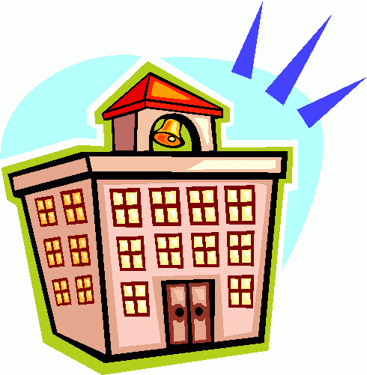  Who’s on the ABS PBIS Leadership Team?  Angela Filion, Principal  Shari Carr, Universal Team Leader/Tree House  Heather Scandale, School Counselor  Chelsea Bissonette, Kindergarten Teacher  Maria McCormack, Grade 1 & 2 Teacher - Harmony  Jamie Saylor, Special Education  David Bolger, Grade 1 & 2 Teacher - Horizon  Kate McLaughlin, Grade 1 Teacher - Synergy  Lyn Porter, PE Teacher - Essential Arts  Laurel Jacobs, Parent Representative  For more information about our  school-wide PBIS system, please  contact Shari Carr at 871-6252 | Parent’s Guide to  PBIS*  at Allen Brook School  (*Positive Behavioral  Interventions and Supports)  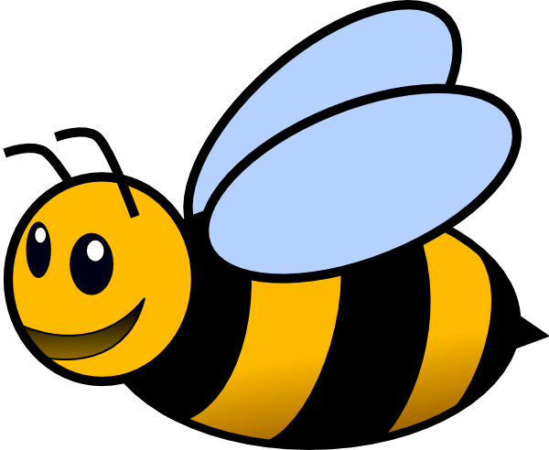  *Be Safe*  *Be Kind*  *Be Responsible*  PreK-Grade 2  Allen Brook School  Williston School District  497 Talcott Drive  Williston, Vermont

What is PBIS?  PBIS-or Positive Behavioral Interventions and Supports-is a school-wide system that recognizes the positive contributions of students. The main goal of PBIS is to help every student at Allen Brook School develop self-regulation skills to make positive choices.  The PBIS process focuses on our school’s ability to teach and support positive behavior expectations for all students. As a result, instructional time is more effectively used for teaching and the overall school environment is calm, pleasant and focused on learning.  Allen Brook PBIS Statement of Purpose:  “To create a positive school culture through common teaching, modeling and practicing school-wide behavior expectations. Making data-based decisions, using a proactive systems approach, will build a community of successful learners.” | Student Recognition  “catch them doing something right”  The Allen Brook staff believes in frequent recognition of students who demonstrate outstanding behavior throughout the day.  In our efforts to recognize, acknowledge and encourage positive behaviors, students are regularly rewarded for their actions with a “Warm Buzzies” (black and yellow pom poms) that are added to a classroom collection “Honey Jar”.  When the class Honey Jar is full the class will have a classroom celebration.  When the Honey Jar is full, the Warm Buzzies are collected and transferred to a school wide “Hive” for collection. When the school fills the “Hive” with Warm Buzzies, there will be a school-wide (all students, faculty and staff) celebration! | Our Allen Brook Pledge is  "To be our best"  Be Safe  Be Kind  Be Responsible  Reinforcing Expectations  Children do their best when they know what is expected of them. However, students often need to be encouraged and taught how to do the right thing.You will notice at ABS, posters that show to staff, students and parents a list of expected behaviors for each school setting. We call this our Behavior Matrix.  Students are taught the behavior expectations at the beginning of the school year and throughout the year. Students learn and practice how to be safe, kind and responsible everywhere at school.

