Practical Trauma-Informed Strategies to Reduce Anxiety in Students
by Jessica Minahan,
author of The Behavior Code and The Behavior Code Companion
jessicaminahan.com
Notetaking Sheet

Impact of Anxiety on behavior and learning

SOS for Teachers
1.Beh is due to underdeveloped skill
2. Beh is communication
3. Beh has function
4. Beh occurs in patterns
5. The only beh you can control is your own
6. Beh can be changed
Why incentives may not be working

Underdeveloped skills:
Self-Regulation
Accurate Thinking
Social Skills
Executive Functioining
Flexible Thinking
FAIR | What are interaction strategies:
Why do some students seek negative attention?
Maintaining Connection to Students  -Connecting  -Reinforcing a sense of control  -Curriculum Considerations | Find School Resources at: https://bit.ly/MINAHANJ
Why breaks may not be helpful and how to change that
-Biofeedback
Transitions
- Stopping
- Pref-nonpref
- Shifting
- Starting
- Downtime
Self-regulation Apps | - Calm - Headspace - Moodnotes (not free) - Moodpath - Pacifica - Pixel Thoughts - SuperBetter (game to teach resilience) - 7 Cups - Anxiety Relief Hypnosis - Happify - Talkspace
Reducing Negative Thinking Toward Writing Tasks

Tips on Giving Demands

Shift Reinforcement
to Skill Development

Jessica Minahan’s Contact Info
Website: www.jessicaminahan.com
Twitter: @jessica_minahan
Facebook Page: The Behavior Code
BOOKS:
The Behavior Code  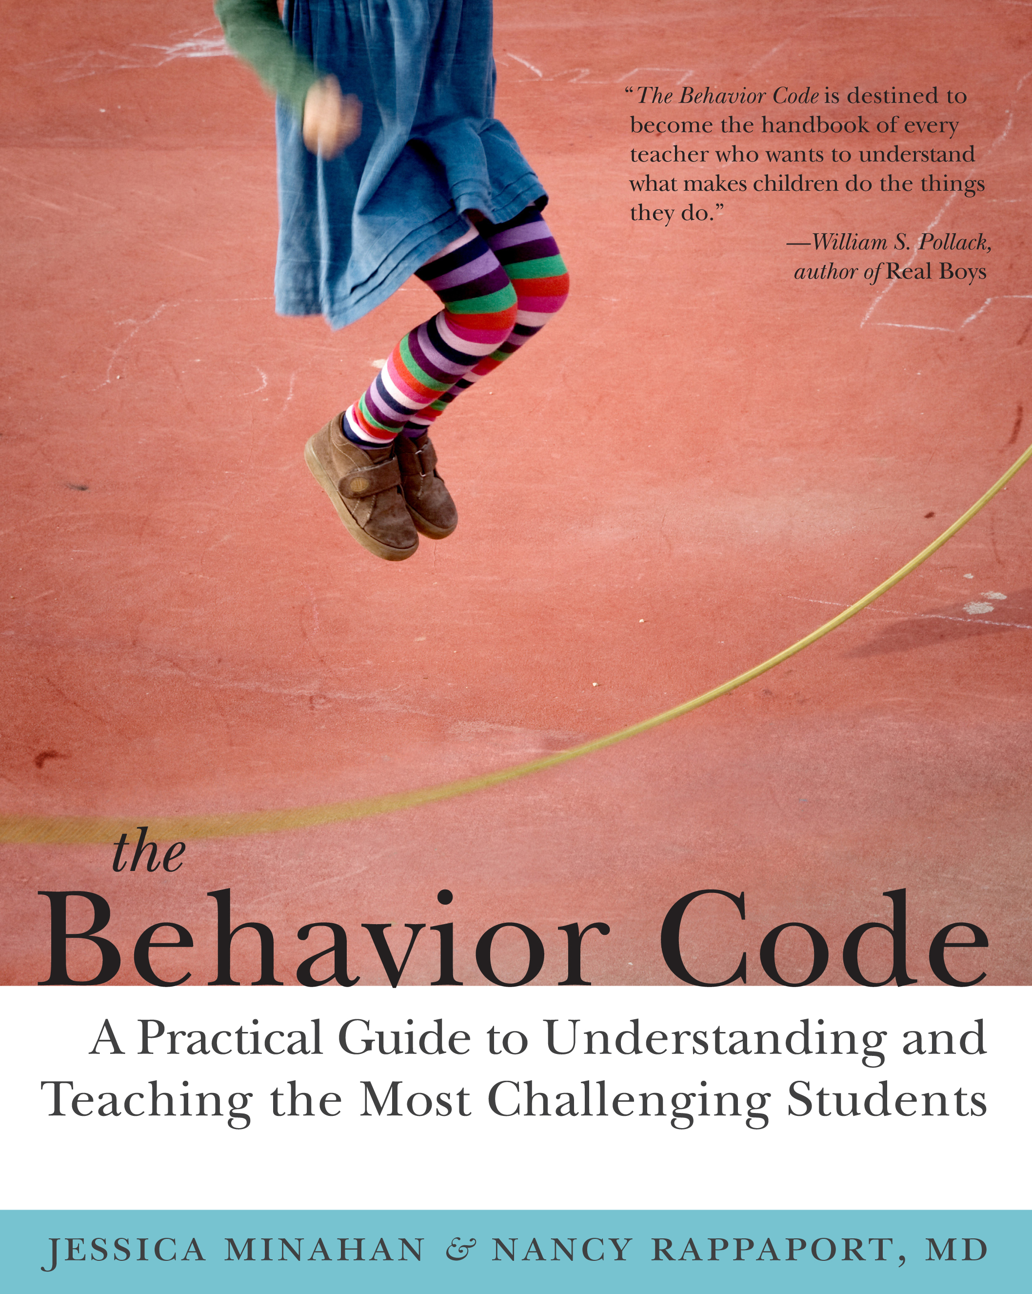 | The Behavior Code Companion  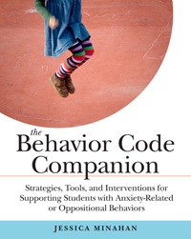

Additional Notes….

