Coordinator Handbook

The purpose of this handbook is to guide the work of Vermont Positive Behavioral Interventions and Supports (VTPBIS) School and SU/SD Coordinators as they work to implement PBIS in their schools and SU/SDs. This handbook will evolve over time as the roles and responsibilities change and improve. For more information, please visit: http://www.pbisvermont.org/resources/coaches-a-coordinators.

Table of Contents:

VTPBIS System of Support………………………………………………………………………..………………….……………… 3
VTPBIS State Technical Assistants…………………………………………………………………………………………………4

VTPBIS SU/SD Coordinator:
SU/SD Coordinator Role Description…………………………………………………………………….……………. 5
SU/SD Coordinator Checklist……………………………………………………………………………………………... 6

VTPBIS School Coordinator:
School Coordinator Role Description.………………………………………………………………..………………. 7
School Coordinator Checklist ……………………………………………………………………………………….……. 8
Coordinators Calendar……………………………..……….………………………………………………………………………….. 9
Guidelines for VTPBIS Network of Active Schools………………………………….……………………………………. 12

VTPBIS System of Support:

Building and sustaining PBIS implementation within a Multi-Tiered System of Supports for Behavior (MTSS-B) requires coordination, coaching, and teaming at all levels. The graphic below describes Vermont’s System of Support including: technical assistance, coaching, and coordination of PBIS at the State, SU/SD, and School Levels.

VTPBIS State TA Role:

The VTPBIS TA structure is organized to provide three types of TA to VTPBIS schools and SU/SDs (see graphic on right). VTPBIS State TAs are available to help SU/SDs and schools navigate the process of exploring, implementing, and sustaining VTPBIS. Support is available through technology (i.e. online mtgs.) and/or 1-2 site visits.
1. SYSTEMS: Specific supports include:
- Determining readiness for VTPBIS training at all tiers;
- Identifying other VTPBIS Professional Learning opportunities;
- Seeking resources to support VTPBIS implementation; and
- Understanding how to access VTPBIS Coaches/Trainers
2. DATA: Specific supports include:
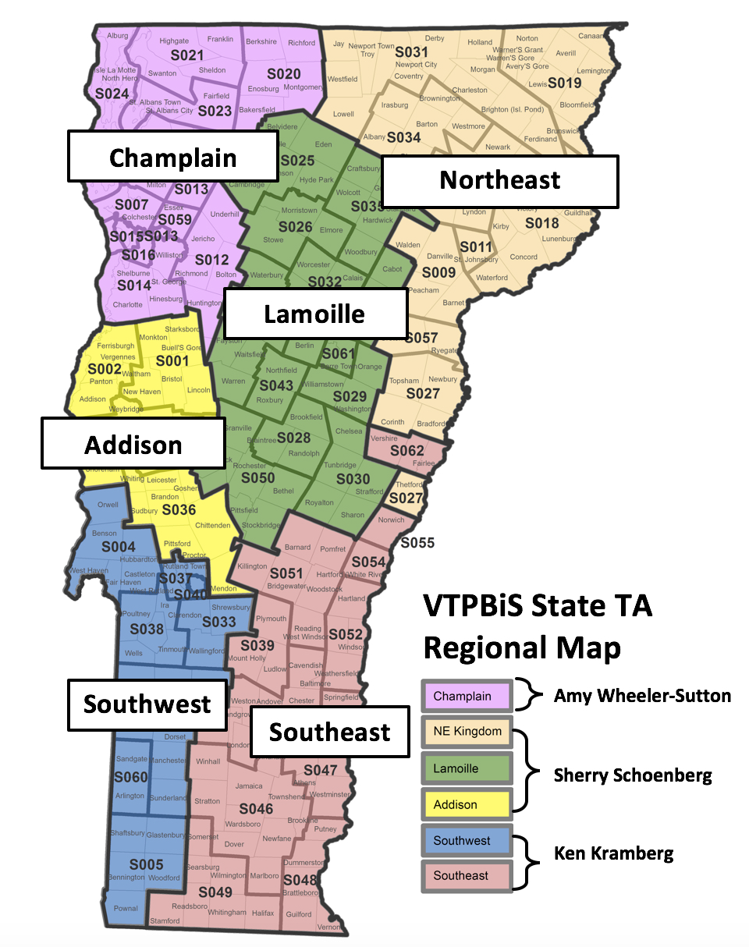
- Understanding and using the VTPBIS data tools (School-wide Evaluation Tool; Self-Assessment Survey, SWIS, etc.);
- Support for SWIS implementation;
- Assistance with problem solving using data; and
- Developing and sharing data with stakeholders
3. PRACTICES: Specific supports include:
- Implementing PBIS with fidelity at all tiers;
- Identifying evidence-based practices; and
- Consultation about implementation dips
To find out who your VTPBIS State TA is,
please see VTPBIS TA Map .

VTPBIS SU/SD Coordinator Role:

VTPBIS Supervisory Union/Supervisory District (SU/SD)
Coordinator Implementation Checklist

SU/SD: _________________________________________________________________________________

PBIS Schools: ___________________________________________________________________________

SU/SD Coordinator Name: _________________________________________________________________

Date of Completion: ______________________________________________________________________
VTPBIS Supervisory Union/Supervisory District Coordinator Checklist | In Place = 2  Partially in Place = 1  Not in Place = 0
Please indicate the status of your efforts to coordinate the PBIS school efforts  within your supervisory union or supervisory district. | Date: | Date: | Date:
- Identified as the SU/District Coordinator for PBIS (endorsed by superintendent; flexibility to complete tasks on time; attended PBIS introductory training) | Status:
- Establish Supervisory Union/District Team that meets 2 times per year | Status:
- Coordinate the school’s completion of the SET (post-implementation only), the Tiered Fidelity Inventory (TFI), and the Self-Assessment Survey (SAS) | Status:
- Act as liaison between schools and VTPBiS State Implementation Team | Status:
- Attend School-based Leadership Team meetings 2-3 times per year | Status:
- Create dissemination strategy to establish visibility | Status:
- Ensure social/behavior is a top priority of the district/SU and integrated with other initiatives | Status:
- Secure resources/funding for school teams | Status:
- Create capacity for staff training through SU training calendar | Status:
- Ensure school has data-based information system to make PBIS decisions | Status:
- Review schools’ behavior data 3-4 times per year | Status:
- Participate in “Data Days” two times a year (as facilitator or participant) | Status:

What is your action plan for completion of activities?

VTPBIS School Coordinator Role:

VTPBIS School Coordinator Implementation Checklist

SU/SD: _________________________________________________________________________________

PBIS Schools: ___________________________________________________________________________

SU/SD Coordinator Name: _________________________________________________________________
Date of Completion: ______________________________________________________________________
VTPBIS School Coordinator Checklist | In Place = 2  Partially in Place = 1  Not in Place = 0
Please indicate the status of your efforts to coordinate PBIS within your school. | Date: | Date: | Date:
1. Identified as the School Coordinator .1 FTE (endorsed by administrator; flexibility to complete tasks on time; attend VTPBIS trainings) | Status:
2. Ensure team is scheduled to meet at least monthly | Status:
3. Help team with meeting facilitation, organization, and task completion around PBIS School Implementation Plan | Status:
4. Act as liaison between your school and SU/District Coordinator and SU/District Leadership Team | Status:
5. Attend VTPBIS Regional School Coordinator meetings | Status:
6. Create dissemination strategy to establish visibility | Status:
7. Organize and report PBIS data to Team, School, and State | Status:
8. Assist in securing needed resources for school team | Status:
9. Reinforce school staff (positive nag!) | Status:
10. Ensure your leadership team completes the necessary fidelity measures (SET, SAS, TFI) and uses data to make decisions | Status:
11. Participate in “Data Days” two times a year (as facilitator or participant) | Status:

What is your action plan for completion of activities?

Calendar of Activities for

VTPBIS SU/SD Coordinators and School Coordinators

Month: | Activities:
July -September | School Coordinators:  - Complete VTPBiS Action Plan for Sustainability VTPBIS Action Plan for Sustainability (doc)  - Rollout (Staff, Students, Families, and Community)  - Update contact information by contacting Anne Dubie at anne.dubie@uvm.edu  - Review the PBIS/BEST PD calendar and identify trainings for the upcoming year  SU/SD Coordinators:  - Make contact with your School Coordinators  - Schedule 2 to 3 meetings with each school leadership team  - Attend PBIS school-based leadership team meetings  - Establish SU/SD Team that meets 2 times per year  - Touch base with your State TA about resource and PD needs  - Review the PBIS/BEST PD Calendar and support your schools in determining what trainings they may need throughout the year
October | School Coordinators:  - Review September ODR data (SWIS or other school-wide information system)  - Receive SWIS Invoices and process for payment (if applicable)  - Attend Annual PBIS Leadership Forum. Receive annual PBIS school acknowledgements and share with SU/District/School/Community  - Use Team Implementation Checklist at http://www.pbisvermont.org/resources/evaluation-tools/tic (recommended as an optional planning tool for new schools)  SU/SD Coordinators:  - Schedule and conduct post-implementation SETs (for new schools only)  - Attend Annual PBIS Leadership Forum. Receive annual PBIS school acknowledgements and share with SU/District/School/Community  - Review schools’ data and provide observations and feedback
November | School Coordinators:  - Publicize and celebrate annual state level PBIS acknowledgements  - Review October ODR data (SWIS)  - Re-teach expectations, if needed  - Plan/conduct post-implementation SET (new schools only)  SU/SD Coordinators:  - Conduct SU/SD Leadership Team Meeting  - Review schools’ data and provide observations and feedback
December | School Coordinators:  - Run SWIS Data Integrity Report  - Register for Coordinators Meeting in January  - Review November ODR data (SWIS)  SU/SD Coordinators:  - Review school data and provide observations and feedback  - Host/attend Data Day with your school leadership teams  - Register for Coordinators Meeting in January
January | School Coordinators:  - Review December ODR data (SWIS)  - Re-teach expectations, if needed  - Complete Self-Assessment Survey (SAS between January 1 and March 31  - Complete Tiered Fidelity Inventory (TFI) between January 1 and March 31  - Attend Regional Coordinators Meeting  SU/SD Coordinators:  - Attend PBIS school-based leadership team meetings  - Prompt schools to complete Self-Assessment Survey (SAS) between January 1 and March 31 and Tiered Fidelity Inventory (TFI) between January 1 and March 31  - Attend Regional Coordinators Meeting
February | School Coordinators:  - Review January ODR data (SWIS)  - Review Working Smarter, Not Harder Matrix with School Leadership Team to streamline, coordinate, eliminate  - Help plan a booster or refresher training before or after school vacation  - Complete Self-Assessment Survey (SAS) between January 1 and March 31  - Complete Tiered Fidelity Inventory (TFI) between January 1 and March 31  - SU/SD Coordinators:  - Prompt schools to complete Self-Assessment Survey (SAS) between January 1 and March 31 and Tiered Fidelity Inventory (TFI) between January 1 and March 31  - Review school data and provide observations and feedback
March | School Coordinators:  - Review February ODR data (SWIS)  - Complete Self-Assessment Survey (SAS) between January 1 and March 31  - Complete Tiered Fidelity Inventory (TFI) between January 1 and March 31  SU/SD Coordinators:  - Prompt schools to complete Self-Assessment Survey (SAS) between January 1 and March 31 and Tiered Fidelity Inventory (TFI) between January 1 and March 31  - Attend PBIS school-based leadership team meetings
April | School Coordinators:  - Review March ODR data (SWIS)  - Update action plan based on SAS and TFI  - Register for Coordinators Meeting in May  - SU/SD Coordinators:  - Provide feedback on the SAS using SAS Summary Form  - Review completed TFI at www.pbisapps.org and provide observation and feedback to coordinators  - Review school data and provide observations and feedback  - Conduct SU/SD Leadership Team Meeting  - Register for Coordinators Meeting in May
May | School Coordinators:  - Review April ODR data (SWIS)  - Attend Regional Coordinators Meeting  - Nominate your school for an Annual Acknowledgement  SU/SD Coordinators:  - Prompt schools to determine PD needs for next year based on needs identified using data  - Attend Regional Coordinators Meeting  - Prompt schools to complete steps needed to attend training at Summer Institute (if applicable)  - Encourage your schools to nominate themselves for an Annual Acknowledgement
June | School Coordinators:  - Review May ODR data (SWIS)  - Print “School Summary” report (SWIS)  - Share successes with stakeholders  - Celebrate with staff  - Schedule pre-service and in-service meetings for next year  SU/SD Coordinators:  - Review your school(s) Implementation Plan and facilitate action steps for next year  - Celebrate your school(s) successes  - Report highlights and successes at end of the year School Board Meeting

NOTES & OTHER IMPORTANT ACTIVITIES:

Guidelines for VTPBIS Network of Active Schools:

Inclusion in the VTPBIS Network of Schools is demonstrated by the following:

- Data: The school completes annual assessments (SAS and TFI).

- Communication: Contact with an Implementation Coach or State TA is maintained. Communication between the school and its Supervisory Union/Supervisory District Coordinator is ongoing.

- Participation: Relevant staff attends VTPBIS Regional Coordinators meetings and the Annual VTPBIS Leadership Forum in the Fall.

- Training: School Teams need to be trained by a VTPBIS state-recommended trainer. For questions please contact your State TA.

Inclusion in the Network results in access to technical assistance, implementation coaching, and VTPBiIS training. Network schools will be included in all electronic communications and will be eligible to receive annual VTPBIS acknowledgements based on fidelity of implementation.

