VTPBiS Matters Newsletter ISSUE: Oct 2015

This is a regular publication of the VTPBiS State Team. In order to continue receiving this newsletter, please remember to update your contact information by contacting Anne Dubie at anne.dubie@uvm.edu.

Another Stellar VTPBiS Year!
The VTPBiS State Team is pleased to share with you the 2015 VTPBiS Annual Report at http://www.uvm.edu/cdci/best/pbswebsite/2015VTPBiSAnnualReport.pdf Congratulations to everyone who contributed toward creating better academic and behavioral outcomes for Vermont students!
2015 Vermont PBIS Annual Forum: A time for learning new ideas, networking with peers and celebrating successes! Vermont PBIS school teams were as brilliant as the autumn leaves at the second annual VTPBiS Leadership Forum on October 9th in Killington. 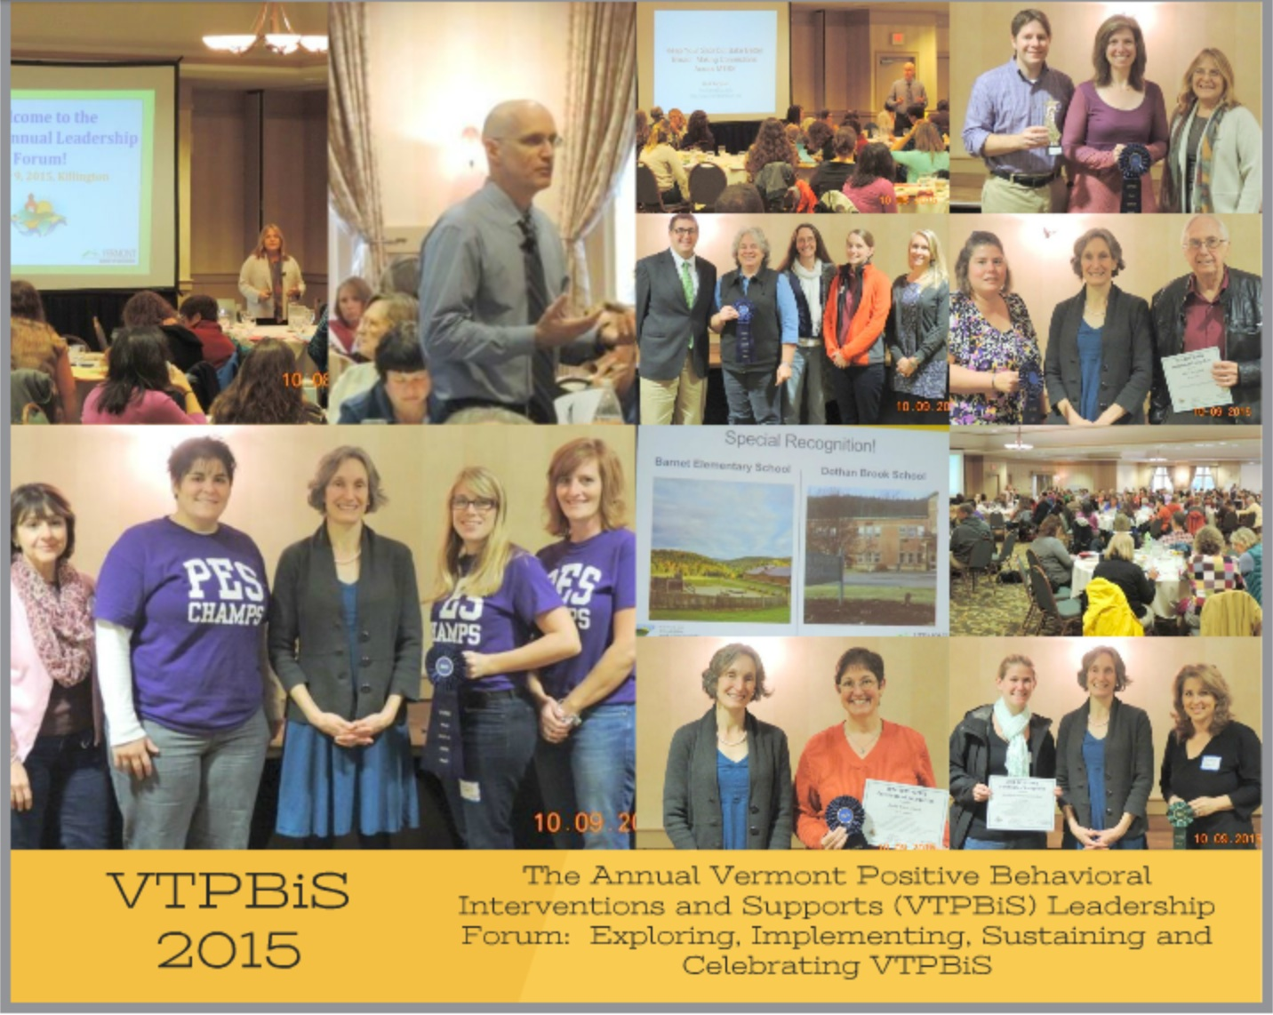While the rain was falling outside, the light was shining inside as 65 VTPBiS school teams and partners participated in networking learning sessions and received acknowledgements for their PBIS accomplishments! Keynote speaker, Hank Bohannon kept folks engaged throughout his presentation about the importance of making intentional connections across multi-tiered systems of supports. Agency of Education Secretary, Rebecca Holcombe, joined the celebration in style as presenter of VTPBiS awards, including special awards to Barnet School and Dothan Brook School for achieving VTPBiS Exemplar status for four consecutive years! Here’s what one participant had to say about the event: The overall climate of this event is excellent. So often in education we forget to celebrate the hard work and accomplishment of our organizations accomplish!
VTPBiS School and SU/SD Coordinators - we need your ideas! Please take our short survey at: https://www.surveymonkey.com/r/PN5Z9QZ
Upcoming Events
Crisis Prevention and Intervention (CPI) - Friday, October 30 2015, 8:00am - 4:30pm (check-in 8:00 - 8:30), Windjammer/Best Western, So. Burlington, VT. This full-day workshop or half-day refresher provides training in a safe, non-harmful behavior management system designed to provide for the best possible care, welfare and safety of children who become out-of-control or aggressive.
Cost: $125/person (full course); $67/person (refresher)
For more information and to register go to: https://www.surveymonkey.com/r/72DXXPB
Bullying Prevention and Intervention Webinar - Thursday, November 12, 2015, 9:00am - 11:00am. This webinar will provide an overview of bullying prevention strategies within a multi-tiered framework. Participants will learn about a user friendly bullying prevention curriculum from the National PBIS TA Center. Examples of elementary and middle school lessons will provided.
Cost: FREE
For more information and to register go to: http://uvmcdci.adobeconnect.com/e78ldonlz17/event/registration.html
Functional Behavioral Assessment (FBA) and Behavior Support Planning (BSP) - Friday, November 13 & 20, 2015, 8:00am - 4:30pm (check-in 8:00 - 8:30), Windjammer/Best Western, So. Burlington, VT. A small group of individuals will be identified by the School Leadership Team to learn how to conduct FBAs/BIPs. This regional training is two days (separated by one week).
Cost: $175/person
For more information and to register go to: https://www.surveymonkey.com/r/PHDZ7SM
Understanding Trauma within a Multi-tiered System of Supports Webinar - Wednesday, November 18, 2015, 9:00am - 11:00am. This webinar will provide an overview of the impact trauma has on childhood development and access to learning. Strategies for identifying and supporting children who have experienced developmental trauma at all three tiers of support will be presented. Participants will understand what it takes to create a trauma informed learning environment.
Presenter: Kym Asam, LICSW, University of HI
Cost: $50/person
For more information and to register go to: http://uvmcdci.adobeconnect.com/e3rgrq1u81v/event/registration.html
Universal Screening Webinar - Wednesday, December 2, 2015, 9:00am - 11:00am. This webinar describes the features of an early nomination and activation system to help schools determine students who have not responded to core instruction for behavior.
Cost: FREE
For more information and to register go to: http://uvmcdci.adobeconnect.com/e342jqo64uf/event/registration.html
De-escalation and Relationship Building Skills - Friday, December 4, 2015, 8:00am - 4:30pm (check-in 8:00 - 8:30), Killington Grand Resort, Killington, VT. A small group of individuals will be identified by the School Leadership Team to learn how to conduct FBAs/BIPs. This regional training is two days (separated by one week).
Cost: $110/person
For more information and to register go to: https://www.surveymonkey.com/r/PHTQ9MQ
Social Skills Webinar - Wednesday, December 9, 2015, 9:00am - 11:00am. This webinar will introduce best practices in teaching social skills within a multi-tiered system of support. Included will be an overview of two models of social skill training - Social Cognition and the Second Step curriculum. The webinar will conclude with a discussion of how to embed social skills curriculum within a multi-tiered framework.
Cost: $50/person
For more information and to register go to: http://uvmcdci.adobeconnect.com/e6a7kgslv51/event/registration.html
Is this Newsletter working for you? Contact us and let us know what you think!

