VTPBiS Quarterly Report

Spring 2016

“It was very helpful to have time to connect with colleagues from around the state on what is working in their schools for PBIS implementation. Additionally, it was wonderful to have direct instruction and time to analyze our school data and complete an action plan for our school.” – Participant at VTPBiS Regional Coordinators Meeting

The VTPBiS State Team is pleased to report on the quarterly progress of PBIS in Vermont. PBIS stakeholders know that commitment to evaluation is a key feature of PBIS implementation as it assists in decision-making at the school, supervisory union/district, and state levels. Our model of evaluation is based on the PBIS National Technical Assistance Center’s Evaluation Blueprint for PBIS. This quarter’s evaluation report is based on the core indicators of Input, Fidelity, Impact, and Sustainability.

INPUT

The VTPBiS State Team continues to develop and deliver high quality training opportunities that yield high rates of participant satisfaction. So far this year, 617 people attended 25 training events with an average participant rating of 98.4% highly satisﬁed or satisﬁed. The chart below lists the learning events that have occurred from September 1, 2015 through May 10, 2016, including satisfaction results.

FIDELITY
This spring, VTPBiS schools completed their annual PBIS fidelity assessments – the Self-Assessment Survey (SAS) and the Benchmarks of Quality (BoQ). The SAS measures staff perceptions of the implementation status and improvement priority for school-wide, classroom, non-classroom, and individual student systems. The BoQ measures fidelity of implementation at the Universal Level. This year, 76% of schools completed the SAS and 87% completed the BoQ (See chart on right).

A score of 70% or higher on the BoQ indicates fidelity of PBIS implementation at the Universal Level. Over the past four years, the overall average BoQ fidelity score for all schools implementing PBIS is 78%.
70%

IMPACT

To assess the impact of PBIS on academic achievement we look at the rate of office discipline referrals (ODRs) correlated with academic data. Research suggests that students who are in class and on task have greater access to academic instruction, thus increasing opportunities for learning. The VTPBiS Annual Report will highlight ODRs and academic achievement once SY ‘16 data is available.
PBIS Impact at Barnet School:
For this Report, we are pleased to provide a snapshot of changes in Barnet School’s ODRs over time. The graph on the right outlines the number of ODRs at the Barnet School over the past seven years. In their first year of PBIS implementation and documentation of problem behaviors, Barnet School had an overwhelming number of students missing learning opportunities because of problem behaviors – 2,405 students! Each year since, behavior at Barnet school has improved. The current number of referrals, 169 (as of March, 2016) is a fraction of the number just a few years ago. This transformation is a direct result of Barnet School’s implementation of PBIS.

SUSTAINABILITY

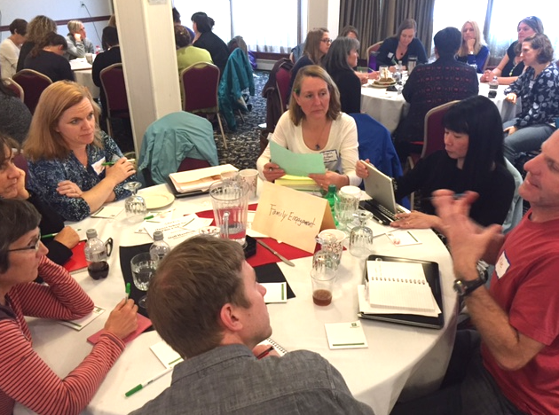
VTPBiS SU/SD and School Coordinators Learning & Networking: Vermont continues to provide high quality professional learning opportunities to educators. This month, 77 VTPBiS SU/SD & School Coordinators and Administrators representing 59 VTPBiS Schools attended the VTPBiS Coordinator as Coaches Learning and Networking Series. Topics included:
- Alignment of MTSS-A and MTSS-B
- Strategies in Non-Classroom Settings
- Tier II/Tier III Strategies
- Social Media
- Celebrations
- Family Engagement
- Anything Goes

“It was a great idea to offer several topics to choose from to go and listen to others share. Do more of this!” – Participant at May VTPBiS Coordinators as Coaches Meeting
VTPBiS Coordinators discuss strategies for family engagement with Karen Price of the Vermont Family Network

Annual VTPBiS SU/SD Coordinators Checklist:
An important feature of VTPBiS sustainability is the ongoing coordination and support of the VTPBiS SU/SD Coordinators. These individuals are the “glue” that holds together the PBIS efforts across the schools. Thanks to all the VTPBiS SU/SD Coordinators for completing the annual VTPBiS SU/SD Coordinator Checklist. This year we received 25 responses! Results of this Checklist will be used to develop specific supports for VTPBiS SU/SD Coordinators. Here are some strengths and areas in need of improvement derived from the Checklist:

Strengths:
- 100% of the following features are “Fully” or “Partially” in Place:
  - Social/behavior is a top priority in the SU/SD
  - The VTPBiS SU/SD Coordinator role is endorsed by the superintendent
  - Schools have a data system in place to review and analyze behavior
- 96% of the following features are “Fully” or “Partially” in Place:
  - Schools are supported in completing the annual PBIS Assessments
  - VTPBiS SU/SD Coordinator is a liaison between the schools and the State
  - VTPBiS SU/SD Coordinator helps schools secure resources for PBIS

Areas in Need of Improvement:
- 38% of the following features are “Not in Place”
- SU Teams meet twice a year
- SU Coordinator participates in Data Days twice a year

Congratulations to Cindy Cole of Chittenden South Supervisory Union and Donarae Dawson of Washington West Supervisory Union for reporting that 92% of the SU/SD Coordinator functions necessary to support their PBIS schools are “Fully in Place”!

