VTPBiS Quarterly Report
April 2015

Context:

In March, ten Vermont schools received training at the following Tiers:
    - Universal: Barre Town Elementary/Middle and St. Albans Town
    - Targeted: East Montpelier, Fletcher, Summit, Oak Grove
    - Intensive: Bristol, Castleton, Bethel, Bensen

During this quarter, All VTPBiS schools were expected to complete the annual fidelity assessments (Benchmarks of Quality and Self-Assessment Survey) at the Universal Level (see Fidelity below).

Input:

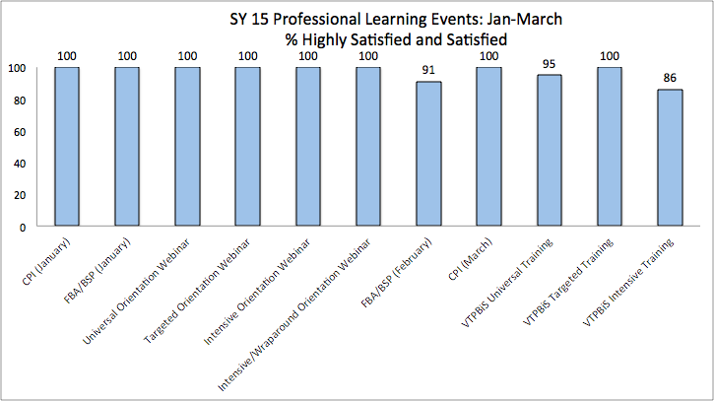
The following chart lists the trainings that have occurred from January through March, 2015 including satisfaction results. Ninety schools and 214 participants attended training during this quarter.
Fidelity:

VTPBiS Schools recently completed the annual Fidelity Assessments – Benchmarks of Quality (BoQ) and the Self-Assessment Survey (SAS). Here is a summary of results:
    - 73% of VTPBiS Schools completed the annual Self-Assessment Survey (SAS)
    - 74% of VTPBiS Schools completed annual fidelity assessments (including the BoQ and Post-Implementation SET)
    - 84% of VTPBiS Schools reported meeting fidelity at the Universal Level of Implementation

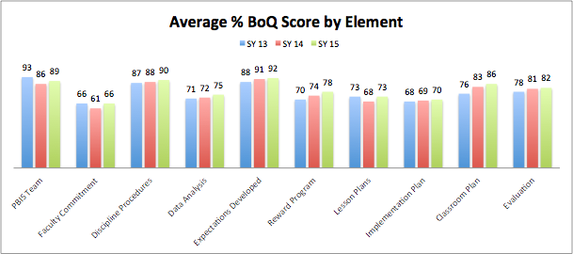
The graph below shows the State Average % BoQ Score by Element for the past three years:
BoQ features “Defining Expectations”, “Reward Systems” and “Classroom Implementation” have increased over the past three years. “Faculty Commitment” and “Implementation Plan” features are areas of need. The Spring VTPBiS Regional Coordinators Meetings’ agenda highlighted strategies for improvement in these areas.

Impact:

A recent review of office discipline referrals (ODRs) for schools using the School-Wide Information System (SWIS) revealed that the two top problem behaviors are physical aggression and non-compliance/defiance (see graph below). The Spring VTPBiS Regional Coordinators Meetings’ agenda highlighted strategies for improvement in these areas.

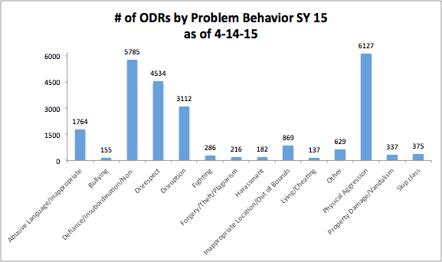
Sustainability:

VTPBiS SU/SD Coordinators recently completed the annual checklist indicating the extent to which they perform the functions needed to carry out this role. Here are highlights.
    - 50% of VTPBiS SU/SD Coordinators completed the checklist
    - 90% features are in place or partially in place

Strengths:
    - VTPBiS SU/SD Coordinator is identified and endorsed by superintendent (96% fully or partially in place)
    - VTPBiS SU/SD Coordinator facilitates the schools completion of annual PBIS assessments (100% fully or partially in place)
    - VTPBiS SU/SD Coordinator ensures that schools have a data-based information system to make PBIS decisions

Areas of Need:
    - VTPBiS SU/SD Coordinator participates in “Data Days” two times per year (60% fully or partially in place)
    - VTPBiS SU/SD Coordinator creates a dissemination strategy to establish visibility of PBIS (80% fully or partially in place)
    - VTPBiS SU/SD Coordinator establishes a SU/SD Team that meets two times per year (84% fully or partially in place)

See graph below for VTPBiS SU/SD Coordinators functions fully or partially in place:
