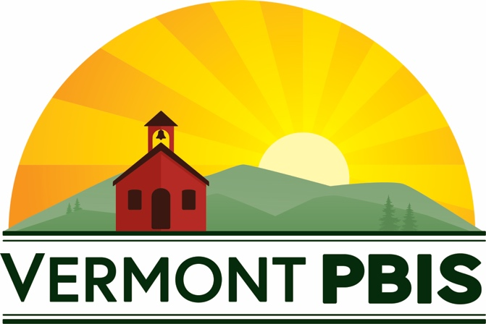

2020 Annual VTPBIS Virtual Forum

October 7th, 2020

Agenda
(For complete session descriptions)
(All forum materials can be found here)
Questions? Contact Anne Dubie @ (802)233-2332

8:30 - 8:45 – Opening Remarks and Acknowledgements –
Sherry Schoenberg and Amy Wheeler-Sutton, Vermont PBIS Coordinators
Link to Join: https://us02web.zoom.us/j/87135793316

8:45 - 9:45 – Keynote Presentation: A VTPBIS Principal’s Perspective: How the strength of our PBIS framework helped us pivot during challenging times.
Rick Dustin-Eichler, Principal, Dothan Brook School
Link to Join: https://us02web.zoom.us/j/87135793316

10:15 - 11:45 – Workshop Sessions (Choose One):

- Introduction to PBIS
Presenters: VTPBIS State Team Members
Link to Join: https://us02web.zoom.us/j/86549948632

- Circles of Support: A Restorative Approach to Staff Wellness
Presenter: Jon Kidde
Link to Join: https://us02web.zoom.us/j/86810351596

- Understanding and Practicing Function-Based Thinking
Presenter: Jeremy Tretiak
Link to Join: https://us02web.zoom.us/j/88542291424

- Crisis Prevention and Response In the COVID-19 Era: What we know and what we’ve learned
Presenters: Ken Kramberg, Amanda Babcock, and Judy Houde-Hardy
Link to Join: https://us02web.zoom.us/j/85995275503

- CANCELLED: Person-Centered Planning for Better Outcomes
Presenter: Sherry Schoenberg
Link to Join:

- Essential Elements of Effective Collaboration: Using the VTmtss Framework to Improve Teaming Infrastructure and Effective Teaming Strategies
Presenters: Meg Porcella and Tracy Watterson, Vermont Agency of Education
Link to Join: https://us02web.zoom.us/j/89954646622

- Expanding your Inventory of Tier II Supports
Presenter: Kristin Beswick
Link to Join: https://us02web.zoom.us/j/85274144751

- Using Data to Determine Universal Interventions
Presenters: VTPBIS State Team Members
Link to Join: https://us02web.zoom.us/j/81747859136

- SEL is Not New: Enhancing What You’re Already Doing
Presenter: Amy Wheeler-Sutton
Link to Join: https://us02web.zoom.us/j/85410600756

- Connecting Thoughts, Feelings, and Behaviors to Better Understand and Support Students with Complex Needs
Presenter: Lauralee Keach
Link to Join: https://zoom.us/j/97386084194

- CANCELLED: Authentic Family and Community Engagement
Presenters: Holly Rouelle, Principal of Chamberlin School and Denise Goodnow, Principal of Thatcher Brook School
Link to Join:

- Nurturing and Supporting Staff Resilience in Challenging Times
Presenters: VTPBIS State Team Members
Link to Join: https://us02web.zoom.us/j/89584672597

- ISF Learning and Networking Session - From Planning to Action and Back Again
Presenters: Ami Flamini, Kim Yanek, and Kym Asam
Link to Join: https://us02web.zoom.us/j/84894966203

LUNCH ON YOUR OWN

12:30 - 1:15 – (Optional) Ignite Sessions or Team Time:

- VTPBIS Coordinators Networking Meeting (for school + SU/SD VTPBIS Coordinators) - Link to Join: https://zoom.us/j/92100538672
- SWIS Q & A - Link to Join: https://us02web.zoom.us/j/85855154153
- Rule 4500 and New AOE Guidance - Link to Join: https://us02web.zoom.us/j/83369157335
- Equitable Systems, Data, and Practices within PBIS – Link to Join: https://zoom.us/j/94161567189

1:30 - 3:00 – Afternoon Workshops Sessions with Featured National Speakers (Choose One):

- Using Your MTSS Framework to Navigate the 2020-2021 School Year
Presenter: Brandi Simonsen, Co-Director PBIS Center
Link to Join: https://us02web.zoom.us/j/81123018415

- Considerations for Systematic Screening PK-12 in the COVID-19 Era: Universal Screening for Internalizing and Externalizing Behaviors
Presenter: Kathleen Lane, Professor in the Department of Special Education at the University of Kansas and Associate Vice Chancellor for Research
Link to Join: https://us02web.zoom.us/j/88139680628

- Centering Equity & Reducing Student Discipline through Culturally Sustaining Instructional Practices
Presenter: Ruthie Payno-Simmons, Equity Implementation Specialist, Michigan’s Multi-Tiered System of Supports Technical Assistance Center
Link to Join: https://zoom.us/j/91306255435

- Mental Health in Schools: All Hands-on Deck!
Presenter: Susan Barrett, Director for Social Behavior Supports, Old Dominion University
Link to Join: https://zoom.us/j/97490550307

